 Revision Term I

EXAMINATION

DECEMBER 2023 - 24

Key Stage 3 (Year VII __)

**Date : November 2023**

**Name of the Candidate : _______________________________________________**

**Subject : CS – Theory**

**Total Maximum Marks : 80**

**INSTRUCTIONS**

**Answer all questions.**Use a black or dark blue pen.  
Write your name, centre number and candidate number in the boxes at the top of the page. Write your answer to each question in the space provided.  
Do **not** use an erasable pen or correction fluid.  
Do **not** write on any bar codes.  
You may use an HB pencil for any diagrams, graphs or rough work.

**The total mark for this paper is 80.**The number of marks for each question or part question is shown in brackets [ ].  
No marks will be awarded for using brand names of software packages or hardware.

|  |  |  |
| --- | --- | --- |
| **Section** | **Maximum Marks** | **Marks Obtained** |
| **A** | **26** |  |
| **B** | **48** |  |
| **C** | **6** |  |
| **Total** | **80** |  |

**Checked by : ____________________________**

**Re-checked by : ____________________________**

**Section A**

1. Tick (✓) whether the following are examples of internal or external hardware devices.

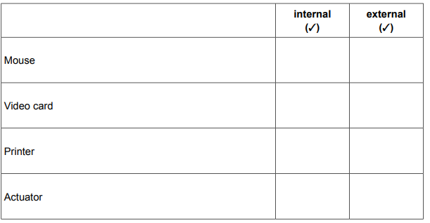 [2]

1. Geeta spends a great deal of time at work entering data into her computer. State three items of hardware that Geeta should be provided with to help avoid RSI when she enters data into the computer.

1…………………………………………………………………………………………………………………………………………………………………………………………………………………………………………….....2……………………………………………………………………………………………………………………………………………………………………………………………………………………………………………..…3……………………………………………………………………………………………………………………………………………………………………………………………………………………………………………[3]

1. Tick whether the following statements are true or false

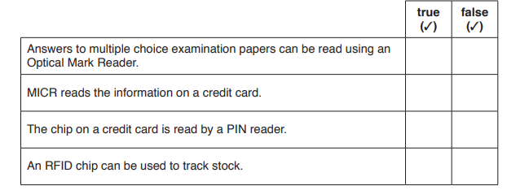 [2]

1. Laptop computers are often equipped with Solid State Drives (SSD) or Hard Disk Drives (HDD).

(a) Give four advantages of SSD compared to HDD.

1……………………………………………………………………………………………………………………………………………………………………………………………………………………………………………......2………………………………………………………………………………………………………………………………………………………………………………………………………………………………………………..

3………………………………………………………………………………………………………………………………………………………………………………………………………………………………………………..

4……………………………………………………………………………………………………………………………………………………………………………………………………………………………………………. [4]

(b) People now tend to buy laptops rather than desktop computers. Despite this, desktop computers are

still fairly popular. Describe three advantages of using a desktop computer rather than a laptop

computer.

1……………………………………………………………………………………………………………………………………………………………………………………………………………………………………………......2………………………………………………………………………………………………………………………………………………………………………………………………………………………………………………..

3…………………………………………………………………………………………………………………………………………………………………………………………………………………………………………….[3]

1. Tick whether the following are examples of System software or Applications software.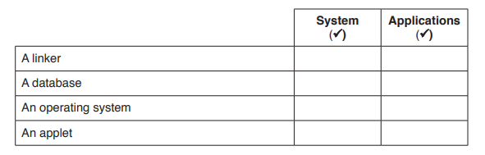 [2]
2. Circle two items which are used as internal hardware devices.

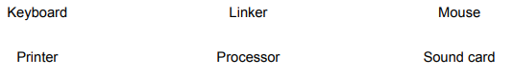 [2]

1. Tick whether the following statements refer to 3D printers, Laser printers or Dot matrix printers.

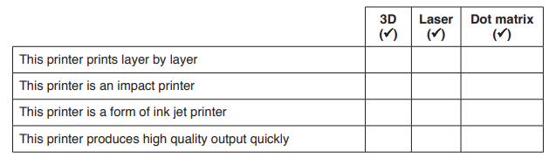[4]

**Section B**

1. When a student has finished working on an existing file, the software gives her two options, Save and Save As.

Explain two differences between Save and Save As.

1……………………………………………………………………………………………………………………………………………………………………………………………………………………………………………......2……………………………………………………………………………………………………………………………………………………………………………………………………………………………………………[2]

1. A public garden in Canada has a computerised greenhouse to grow rare plants.

(a) Name three sensors which would be used in a computerised greenhouse.

1………………………………………………………………………………………………………………………

2………………………………………………………………………………………………………………………

3……………………………………………………………………………………………………………………[3]

(b) To maintain the environment the sprinkler system sprays water on the plants for four hours each day. Describe how a microprocessor uses the data from a timer to control the sprinklers in the computerised greenhouse.

………………………………………………………………………………………………………………….……..……………………………………………………………………………………………………………..………….………………………………………………………………………………………………………..……………….…………………………………………………………………………………………………..…………………….……………………………………………………………………………………………..………………………….………………………………………………………………………………………..……………………………….…………………………………………………………………………………..…………………………………….……………………………………………………………………………..………………………………………….………………………………………………………………………..……………………………………………….…………………………………………………………………..……………………………………………………..……………………………………………………………...………………………………………………………..……………………………………………………..………………………………………………………………[6]

1. State two benefits to a company of using robots on car production lines.

1……………………………………………………………………………………………………………………………………………………………………………………………………………………………………………......2……………………………………………………………………………………………………………………………………………………………………………………………………………………………………………[2]

1. This diagram shows a smartphone.

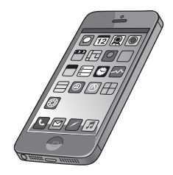

(a) Name three input devices found on a smartphone.

1………………………………………………………………………………………………………………………

2………………………………………………………………………………………………………………………

3……………………………………………………………………………………………………………………[3]

(b) Name one storage device which is available in a smartphone.

……………………………………………………………………………………………………………………..[1]

(c) Name two output devices found in a smartphone. 1………………………………………………………………………………………………………………………

2……………………………………………………………………………………………………………………[2]

1. Tick whether the following statements relate to a command line interface (CLI) or a graphical user interface (GUI).

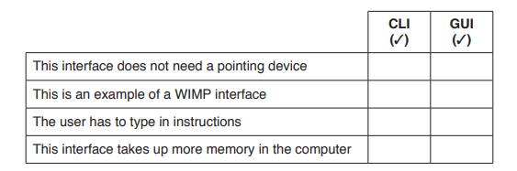 [4]

1. A company is purchasing a new printer. A choice has to be made between using a laser printer or a dot matrix printer. Discuss the advantages and disadvantages of using dot matrix printers rather than laser printers.

………………………………………………………………………………………………………………….……..……………………………………………………………………………………………………………..………….………………………………………………………………………………………………………..……………….…………………………………………………………………………………………………..…………………….……………………………………………………………………………………………..………………………….………………………………………………………………………………………..……………………………….…………………………………………………………………………………..…………………………………….……………………………………………………………………………..………………………………………….………………………………………………………………………..……………………………………………….…………………………………………………………………..……………………………………………………..……………………………………………………………...………………………………………………………..……………………………………………………..………………………………………………………………[6]

1. Complete the following sentences, using the most appropriate items from the list.

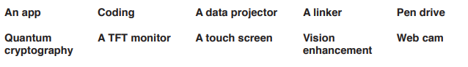

(a)…………………………………………………………………. is an example of system software.

(b) ………………………………………………………………….is an example of an output device that can also act as an input device.

(c) ………………………………………………………………...projects an image inside the headset of the user.

(d) ) ……………………………………………………………….is a form of encryption of data.

[4]

1. A virtual reality (VR) system is being used to train workers in a nuclear power station.

(a) Name any one input devices that could be used with VR systems in this environment. 1………………………………………………………………………………………………………………………

2……………………………………………………………………………………………………………………[1]

(b) Name two output devices that could be used with VR systems in this environment.

1………………………………………………………………………………………………………………………

2……………………………………………………………………………………………………………………[2]

1. IT technicians are setting up a new file server for a school. Describe the benefits and drawbacks of using a command line interface (CLI) rather than a graphical user interface (GUI) to set up a new file server.

………………………………………………………………………………………………………………….……..……………………………………………………………………………………………………………..………….………………………………………………………………………………………………………..……………….…………………………………………………………………………………………………..…………………….……………………………………………………………………………………………..………………………….………………………………………………………………………………………..……………………………….…………………………………………………………………………………..…………………………………….……………………………………………………………………………..………………………………………….………………………………………………………………………..……………………………………………….…………………………………………………………………..……………………………………………………..……………………………………………………………...………………………………………………………..……………………………………………………..………………………………………………………………[6]

1. A computer consists of hardware and software.
2. State what is meant by hardware.

………………………………………………………………………………………………………………….……..…………………………………………………………………………………………………………[1]

1. State what is meant by software.

………………………………………………………………………………………………………………….……..…………………………………………………………………………………………………………[1]

1. There are two types of software. Name one of the two types of software used by a computer

………………………………………………………………………………………………………………….……..…………………………………………………………………………………………………………[1]

1. Name the piece of hardware found in a tablet computer that is both an input and output device.

………………………………………………………………………………………………………………….……..…………………………………………………………………………………………………………[1]

1. A bank has trailed the replacement of Magnetic Ink Character Recognition (MICR) for the details at the bottom of the cheques with bar codes. Describe two advantages of using Magnetic Ink Character Recognition (MICR) rather than bar codes when processing cheques.

………………………………………………………………………………………………………………….……..……………………………………………………………………………………………………………..………….………………………………………………………………………………………………………..……………….…………………………………………………………………………………………………..…………………[2]

1. Data in RAM is accessed more quickly than from a fixed hard disk.

Give two reasons why fixed hard disks are still necessary.

1……………………………………………………………………………………………………………………………………………………………………………………………………………………………………………......2……………………………………………………………………………………………………………………………………………………………………………………………………………………………………………[2]

1. Tick whether the following statements are TRUE or FALSE

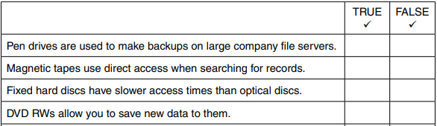

[4]

**Section C**

**21**.Students save and carry their work from school to home on a pen drive.

1. Describe two advantages of a pen drive compared to a CD of doing this.

1……………………………………………………………………………………………………………………………………………………………………………………………………………………………………………......2……………………………………………………………………………………………………………………………………………………………………………………………………………………………………………[2]

(b) Describe two disadvantages of a pen drive compared to a CD of doing this.

1……………………………………………………………………………………………………………………………………………………………………………………………………………………………………………......2……………………………………………………………………………………………………………………………………………………………………………………………………………………………………………[2]