ASSIGNMENT-4
Chapter-1 &2(Marking Scheme)

Sl.No | Answers | Marks
1 | 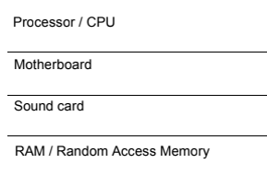 | 1  1  1  1
3 | 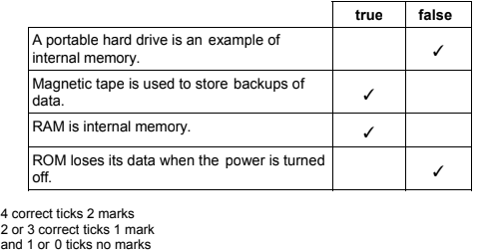 | 4
3 | 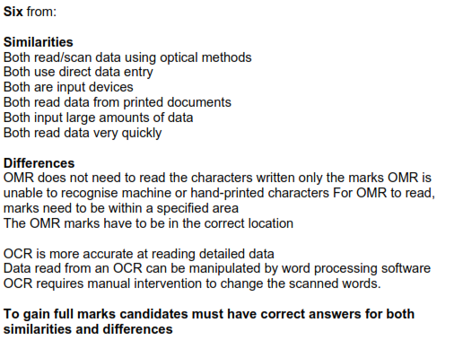 | 6
4.a | 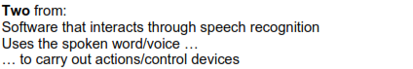 | 2
4.b | 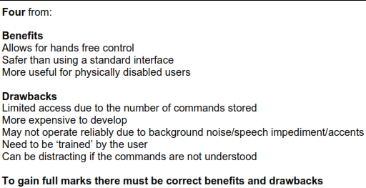 | 4
5. | 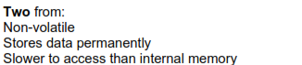 | 2

