**ASSIGNMENT 4**

**Chapter 1 & 2(GRADED)**

1. A computer contains internal hardware.

Write down the most appropriate item of internal hardware to match the descriptions.

(a) This handles all the system instructions.

................................................................................................................................................................ [1]

(b) A printed circuit board that contains the main components of the computer.

................................................................................................................................................................ [1]

(c) This generates output to the speaker.

................................................................................................................................................................ [1]

(d) A type of memory where data is lost when the computer is switched off.

................................................................................................................................................................ [1]

1. Tick whether the following statements about internal and external memory are true or false.

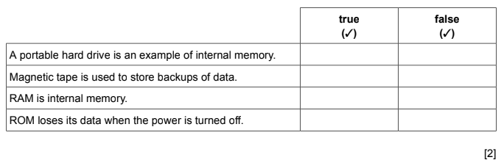

1. Compare Optical Mark Readers(OMRs) with Optical Character Reader(OCRs).Your answer must include similarities and dissimilarities

……………………………………………………………………………………………………………………………………………………….………………………………………………………………………………………

……………………………………………………………………………………………………………………………………………………….………………………………………………………………………………………

……………………………………………………………………………………………………………………………………………………….…………………………………………………………………………………........……………………………………………………………………………………………………………………………………………………………………………………………………………………………………………………………………………………………………………………………………………………………………………………………………………………………………………………………………………………………[6]

1. Some people use Dialogue based interfaces to operate their car audio systems
2. Describe what is meant by Dialogue based interfaces

……………………………………………………………………………………………………………………………………………………….…………………………………………………………………………………........…………………………………………………………………………………………………………………………………………………………………………………………………………………………………[2]

1. Describe the benefits and drawbacks of Dialogue based interfaces this way.

……………………………………………………………………………………………………………………………………………………….…………………………………………………………………………………........…………………………………………………………………………………………………………………………………………………………………………………………………………………………………………………………………………………………………………………………………………………………………………………………………………………………………………………………………………………………………………………………………………………………………………………………………[4]

1. Hard disks and Blu-ray discs are examples of backing storage.

State two characteristics of backing storage

1…………………………………………………………………………………………………………….………………………………………………………………………………………………………………………..2…………………………………………………………………………………………………………….……………………………………………………………………………………………………………………...[2]