**Identify and circle all the 7 Heavy letters**

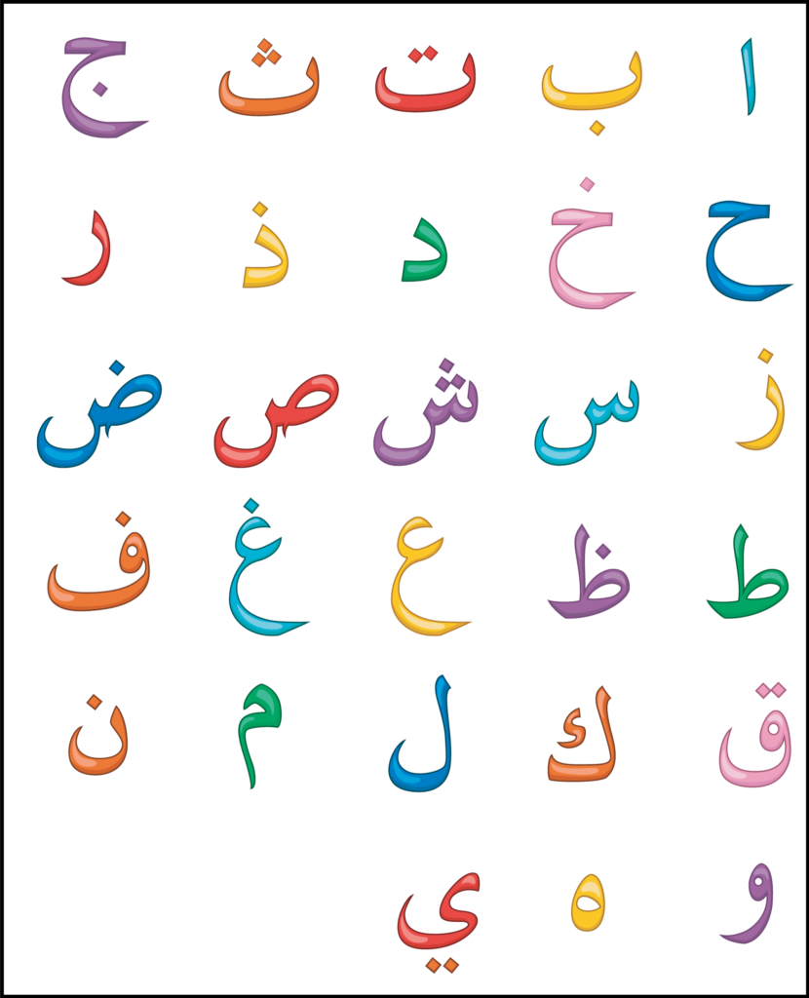

**Color all the Heavy letters from the following Quranic words**

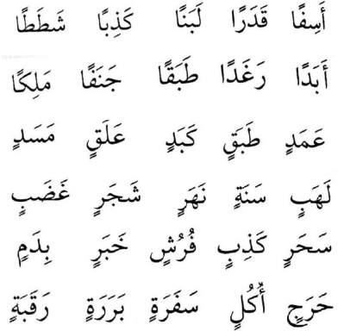

**Identify all 7 Heavy letters from the following Quranic words**

