**QUIZ-3**

**DESIGN STAGE(GRADED)**

1. Validation is a way of checking data in a database.

Name the most appropriate validation check that matches each description below.

Makes sure that the data entered into a field is exactly 10 characters..................................................

...............................................................................................................................................................

Makes sure that a number lies between 10 and 100.............................................................................

...............................................................................................................................................................

Makes sure that the data entered is numeric.........................................................................................

...............................................................................................................................................................

Makes sure that the date is entered as DD/MM/YYYY..........................................................................

...........................................................................................................................................................[4]

1. Carlos is designing a new Computer system to replace an existing system.

Tick four items which will need to be designed.

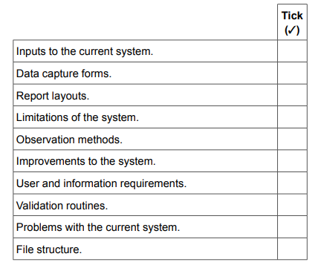 [4]

1. As the data is entered into a company it will need to be verified.

Name two ways in which the data could be verified.

1……………………………………………………………………………………………………………………….……………………………….………………………………………………………………………………………..

2……………………………………………………………………………………………………………………….……………………………………………………………………………………………………………………..[2]