QUIZ-3
DESIGN STAGE (Marking Scheme)

Sl.No | Answers | Marks
1 | 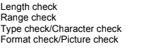 | 4
2 | 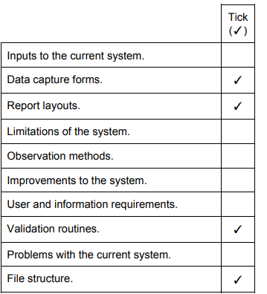 | 4
3 | 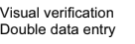 | 2

