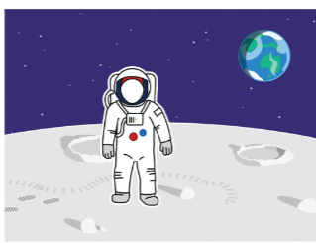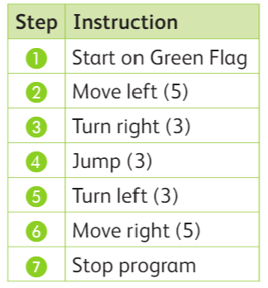

Look at the code and algorithm for the Astronaut.The program has errors.  
Find the errors and fix it.   
