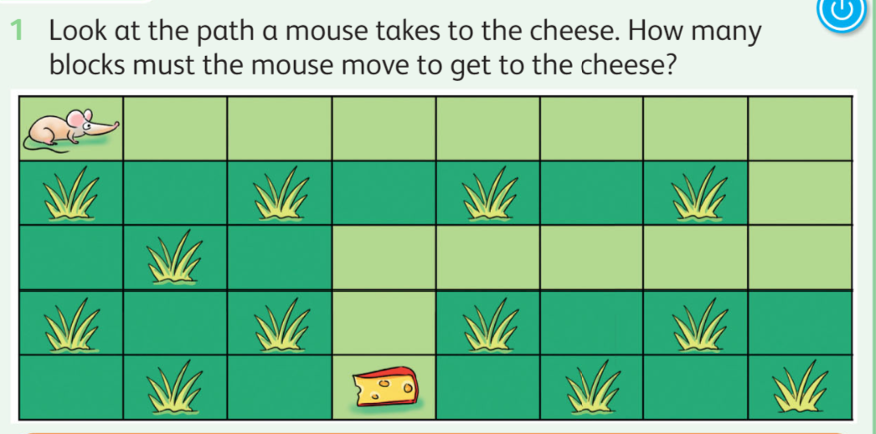

Answer:  
___________________________________________________________________________  
  
2. The code below contain errors , find the errors and fix it .

