|  |  |  |
| --- | --- | --- |
| Term: II  Session: 2022 – 2023 |  | Name: Date: |

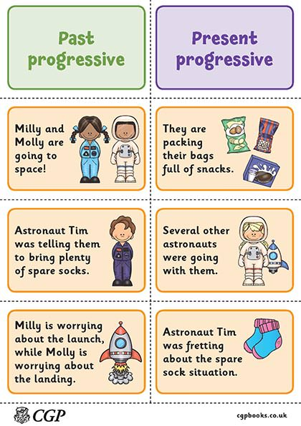

Lit-II Revision Spougmay Mansoor