|  |  |  |
| --- | --- | --- |
| Term: II  Session: 2023 – 2024 |  | Name: Date: |

Read the recount and answer the question.

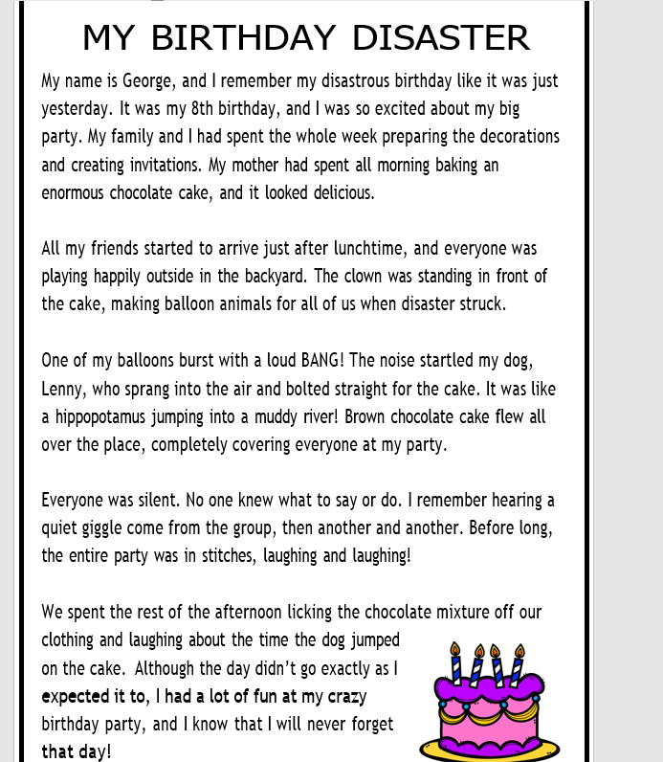

Lit -II Revision-worksheet 3 Spougmay Mansoor

|  |  |  |
| --- | --- | --- |
| Term: II  Session: 2023 – 2024 |  | Name: Date: |

MY BIRTHDAY DISASTER Comprehension

|  |  |
| --- | --- |
| 1. How old was George turning? | |
|  | |
| 2. **Rewrite the sentence below. Make sure to use proper capitalization and punctuation** | |
| a. did everyone laugh at the disaster  …………………………………………………………………………………………………….. | |
| 3. Write down three past tense verbs from the story and write each word in a sentence. | |
|  |  |
|  |  |
|  |  |
| 4. What startled George’s dog? | |
|  | |
| 5. Why do you think the word “BANG” is written in capital letters? | |
|  | |
| 6. How did the guests react to the cake disaster? | |
|  | |
| 7. Underline the conjunctions in the sentences below. | |

__________________________________________________________________________________________________

Lit -II Revision-worksheet 3 Spougmay Mansoor

|  |  |  |
| --- | --- | --- |
| Term: II  Session: 2023 – 2024 |  | Name: Date: |

|  |
| --- |
| a. George was excited but nervous about his party.  b. The party was going well until the disaster struck. |
| 8.Fill in the blanks with the past progressive form of the verb |
| 1. The clown is making balloon animals for all of us.     The clown ____________________balloon animals for all of us.   1. Lenny is jumping straight for the cake.   Lenny __________ straight for the cake. |

__________________________________________________________________________________________________

Lit -II Revision-worksheet 3 Spougmay Mansoor