**I. Choose the right answer. [6]**

|  |  |  |  |  |  |
| --- | --- | --- | --- | --- | --- |
| **Yes/No** | **Record** | **Data type** | **Field** | **Data** | **Rows and Column** |

1. A data table is divided into ________ and __________. /1
2. In the table each column is also represented as _____________. /1
3. A _____________ is a collection of fields, about the same person or object. /1
4. Each table in the spreadsheet has its own _____________. /1
5. This data type contains only two values, that data type is called as __________. /1
6. _____________ items is the fact and figures(number) entered in each field for each record.

**II. Match the following. [4]**

|  |  |
| --- | --- |
| 6. Text | a. **12/01/2024** |
| 7.Number | b. Do you like cookies- **No** |
| 8.Date/Time | c. Student ID- **1475** |
| 9.Yes/No | d. Student name- **Aisha** |

|  |  |  |  |
| --- | --- | --- | --- |
| 6. | 7. | 8. | 9. |
|  |  |  |  |

**IV. Answer the following.**  [10]

10.Khadija is a database manager in a pizza shop, where she has designed the data table to track pizza sales. Use the provided table to assist her in maintaining the database and addressing the following inquiries. [5]

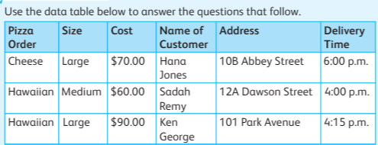

a) List down the names of fields. /1

_______________________________________________________________

_______________________________________________________________

_______________________________________________________________

b) For each field write the data types. /2

_______________________________________________________________

_______________________________________________________________

_______________________________________________________________

_______________________________________________________________

c) Find and list the name of customer who bought large size pizza. /2

_______________________________________________________________

_______________________________________________________________

_______________________________________________________________

_______________________________________________________________

11. Ameera is a club in charger in school, she has created the following table to maintain details of the club students. She needs to find the information for following questions. [5]

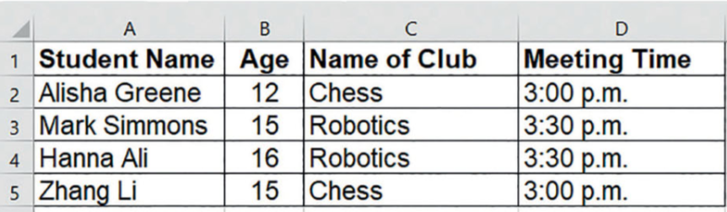

a) How many students age is greater than 12?

i. One

ii. Four

iii. Three

b) Which students have meeting at 3:00pm?

i. Alisha Greene & Hanna Ali

ii. Mark Simmons

iii. Alisha Greene & Zhang Li

c) Which fields did you look at to get the answer for Qb?

i. Student Name

ii. Meeting Time

iii. Name of Club

d) Which club is Mark Simmons in?

i. Chess Club

ii. Robotics

e) Choose the right field name you looked at to find the answer of Qd.

i. Name of Club

ii. Age

iii. Student name