Term: 1 Session:2024-2025 Time: 40 mins

Name: Date:

fruits and vegetables

carbohydrates

proteins

dairy

# These foods are in different food groups. Identify and write the name of the correct food group in each box. / 2.5

**Proteins**

**Carbohydrates**

**Fruits and Vegetables**

**Dairy**

**Fats and sugars**

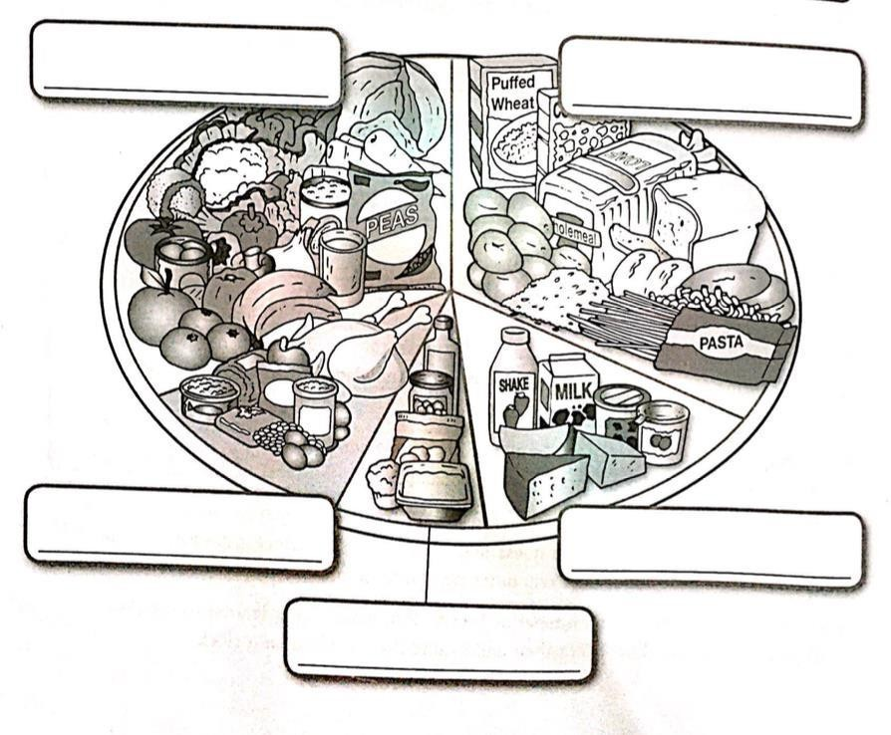

1. **Choose the correct answer. /3**

fats and sugar

* 1. 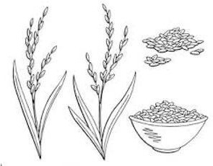Ali will open his fast with bread which is made up of grains. Grains give us energy. They are in the

food group.

* + 1. protein
    2. carbohydrates.
    3. vitamins and minerals
    4. dairy products

Term: 1 Session:2024-2025 Time: 40 mins

Name: Date:

* 1. 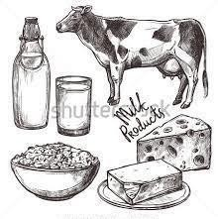Ayaan doesn’t like drinking milk. Encourage him to understand why including dairy in our diet is important for keeping our bones healthy.
     1. It helps make our bone strong.
     2. It helps us to breathe.
     3. It helps make our hair grow.
     4. It gives us energy.
  2. Which food group helps us to grow and repair our muscles and bones?
     1. 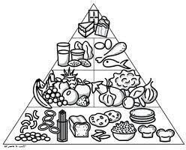protein
     2. carbohydrates
     3. dairy products
     4. Vitamins and minerals

# The following bar chart illustrates the number of portions of fruits and vegetables consumed by John each day. /2

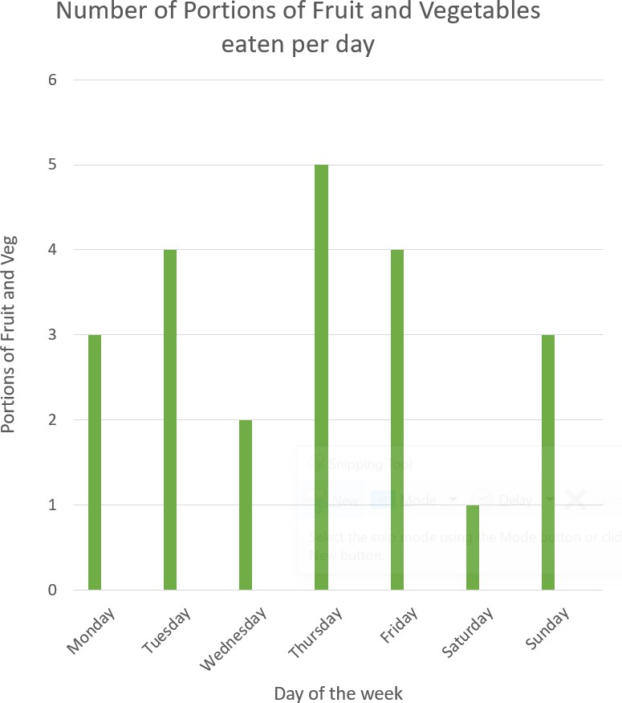

Term: 1 Session:2024-2025 Time: 40 mins

* 1. On which day did John eat the most portions of fruit and vegetables?

Name: Date:

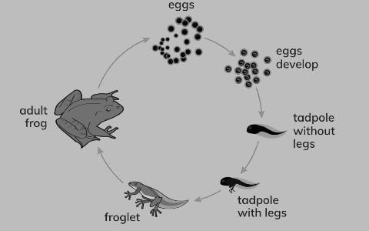

* 1. Do you think a diet consisting only of fruits and vegetables is considered healthy? Why or why not?"
  2. How many portions of fruit and vegetables did john consume on Saturday?
  3. Compare the number of portions eaten on Monday and Tuesday. Which day had more portions, and by how many?

# VI. Look at this style life cycle of a frog. Then answer the questions below. /1.5

1. Which stage follows the tadpole without legs?
2. Which stage follows the small frog with tail?
3. In what two ways is the frog different from the tadpole without legs?

|  |  |  |  |  |  |  |
| --- | --- | --- | --- | --- | --- | --- |
|  | Term: 1 Name:  Session:2024-2025  Time: 40 mins Date:  **V. Write which group each animal belongs to. Choose from these groups /5**  **Fish Insects Reptiles Mammals Amphibians Birds** | | | | | |
|  | **1. hawk** | **2. fish** | **3. frog** | **4. bear** | **5. butterfly** |
|  |  |  |  |  |
| Answer | Answer | Answer | Answer | Answer |
| **6. snake** | **7. ostrich** | **8. lion** | **9. lizard** | **10. shark** |
|  |  |  |  |  |
| Answer | Answer | Answer | Answer | Answer |
|  | | | | | |
| Sci – Yr III Mock Test Ms. Munira | | | | | |

|  |  |  |
| --- | --- | --- |
|  |  |  |
|  |  |  |

Term: 1 Session:2024-2025 Time: 40 mins

Name: Date:

# VI. Draw a food chain including three or more of these living things. /1.5

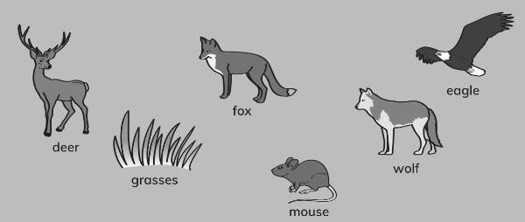

**VII. Answer the following questions about young and adult animals. /1**

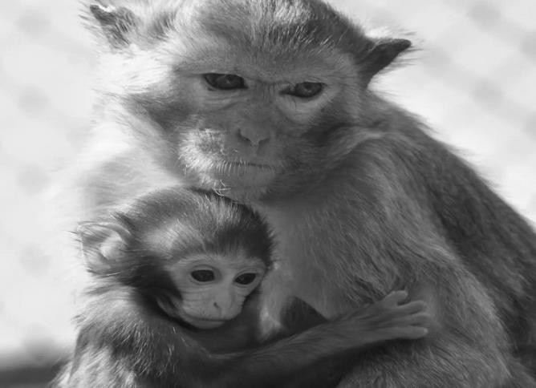

1. How is a baby monkey similar to the adult monkey?
2. Do they both have the same body parts?

Sci – Yr III Mock Test Ms. Munira

|  |  |  |  |
| --- | --- | --- | --- |
| Term: 1 Session:2024-2025 Time: 40 mins  **VIII. Animals need other living things.**  a. If there was no grass what would happen? | | **/3.5** | Name: Date: |
|  |  | | |
| b. If the weather was very cold and the snakes all hid underground. What might happento the hawks. | | | |
|  |  | | |
| c. Which organism in the food chain is a producer? | | | |
|  |  | | |
| d. Which organisms in the food chain are consumers? | | | |
|  |  | | |
| e. Can you think of another organism that could be added to this food chain, and wherewould it fit? | | | |
|  |  | | |
| f. Imagine the bird population increases significantly. How might this impact the rest ofthe organisms in the food chain? | | | |
|  |  | | |
| g. What might happen to the hawk if there is a sudden decrease in the snake population? | | | |
|  |  | | |
|  | | |
| Sci – Yr III | Mock Test | Ms. Munira |