**Revision Worksheet**

**Q1: This is a picture showing the diaphragm muscle as an umbrella. Label which picture shows 'breathe in' and which one shows 'breathe out.'**



**Q2: The following table shows the names of the 5 food groups. Give one example of each food group.**

| a | Carbohydrates |  |
| --- | --- | --- |
| b | Dairy product |  |
| c | Fruits and vegetables |  |
| d | Proteins |  |
| e | Fats and sugar |  |

**Q3: Answer the following questions briefly.**

1. Jack spends more time watching TV and playing video games. What can he do to be healthy?





1. John always likes to eat doughnuts and burgers. Predict what will happen if he eats more fatty and sugary foods in his diet?





1. Ali does not enjoy eating fruits and vegetables. Is his diet balanced? Why is it important to include fruits and vegetables in a healthy diet?





# **Q4: Complete the sentences using words from the box below.**

| carbohydrates | sugars | vitamins |
| --- | --- | --- |
| calcium | proteins |  |

* 1. Fruits and vegetables are packed with that help us fight germs and stay healthy.
  2. Foods like meat, fish, and beans, which are rich in , help our bodies to repair themselves after an injury and help muscles to grow.
  3. , like bread and pasta, give us steady energy and keep us feeling full.
  4. Dairy foods contain to give us strong bones and teeth.
  5. Eating too much of foods high in fats and can cause health problems like weight gain, diabetes, and heart disease.

**Q5: Look at the skeleton below and answer the questions.**

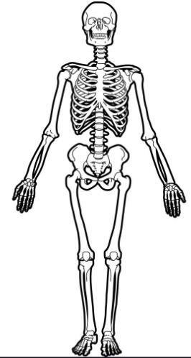

1. Which part of the skeleton serves to protect the brain? Label that part.



1. How many bones make up skeleton?



1. Which foods help strengthen our bones?



1. Which vital organs are protected by the ribcage? Label the ribcage in the picture.



1. What would happen if we had no skeleton?



**Q6: Look at the name of each animal. Put a tick (✔) in the Vertebrates column if it is a vertebrate. Put a tick (✔) in the Invertebrates column if it is an invertebrate. Draw a picture of each animal in the last column.**

| Animal name | Vertebrates | Invertebrates | Drawing |
| --- | --- | --- | --- |
| Fish |  |  |  |
| Butterfly |  |  |  |
| Elephant |  |  |  |
| Spider |  |  |  |
| Snake |  |  |  |

**Q7: Answer the following questions, Write your answers on the blank provided.**

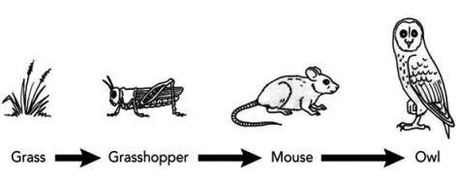

* 1. Grass is an example of a producer, why are producers always plants?



* 1. What is the meaning of the arrows in a food chain?



* 1. The snake is the predator of the mouse, and the mouse is the prey of the snake. What do the terms predator and prey mean?



_

* 1. A mouse is a primary consumer, what do you mean by primary consumer?

**Q8. Observe the different stages of a life cycle of a horse. Answer each question referring on the picture.**

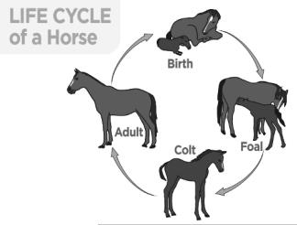

1. Why do you think each stage looks different?



1. What animal group does a horse belong to, and can you explain why? Vertebrates or Invertebrates?



1. What is the name of the stage that comes after the colt? Can you describe the changes that occur during this transition?



**Q9: Create two food chains using the following plants and animals.**

