1. In chemistry, what is meant by the term equilibrium for a reversible reaction?

...............................................................................................................................................................................

...............................................................................................................................................................................

.......................................................................................................................................................................... [3]

1. Nitrogen dioxide, NO2, exists in equilibrium with dinitrogen tetroxide, N2O4.

Nitrogen dioxide is brown and dinitrogen tetroxide is colourless.

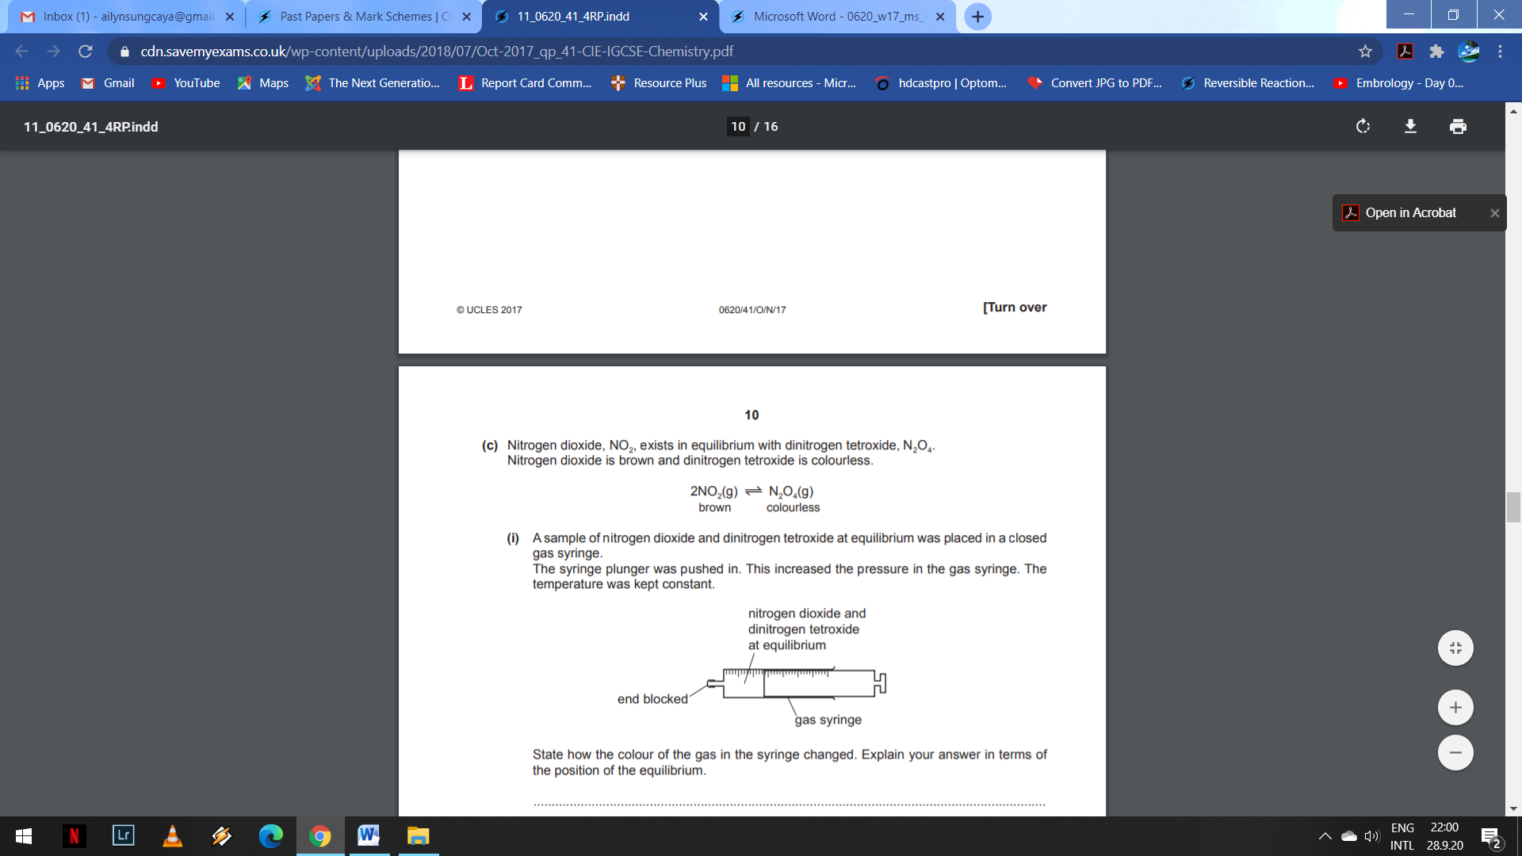

1. A sample of nitrogen dioxide and dinitrogen tetroxide at equilibrium was placed in a closed gas syringe.

The syringe plunger was pushed in. This increased the pressure in the gas syringe. The temperature was kept constant.



State how the colour of the gas in the syringe changed. Explain your answer in terms of the position of the equilibrium. ...................................................................................................................................................................... ...................................................................................................................................................................... ...................................................................................................................................................................... ................................................................................................................................................................ [3]

1. A sealed tube containing nitrogen dioxide and dinitrogen tetroxide at equilibrium was cooled in an ice bath at constant pressure. The contents of the tube became paler.

Suggest an explanation for this observation in terms of the position of the equilibrium. .................................................................................................................................................................... .................................................................................................................................................................... .............................................................................................................................................................. [2]

1. Nitryl chloride, NO2Cl, reacts with nitric oxide, NO. The forward reaction is exothermic.

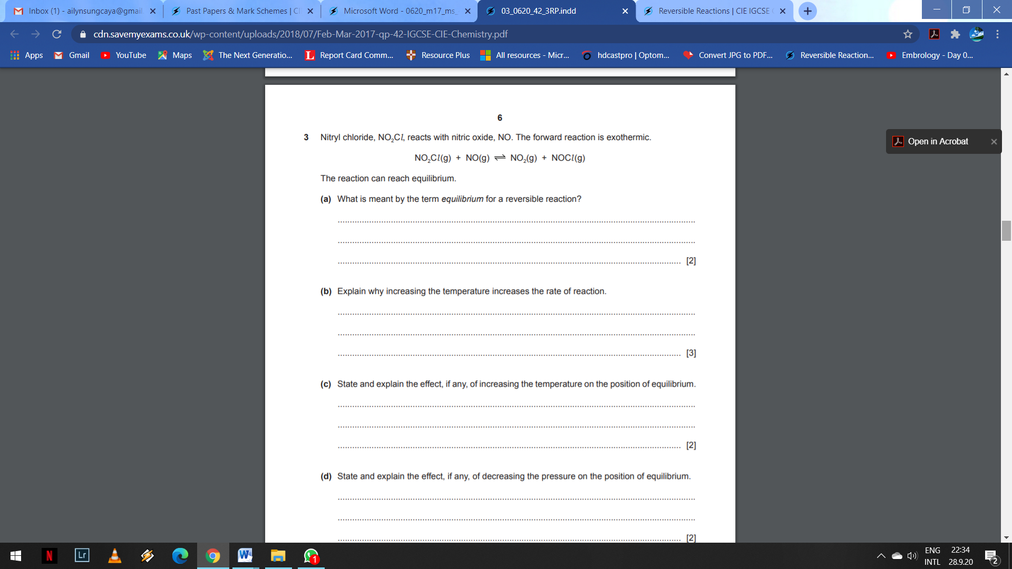

1. Explain why increasing the temperature increases the rate of reaction. ................................................................................................................................................................ ................................................................................................................................................................ ...........................................................................................................................................................[3]
2. State and explain the effect, if any, of increasing the temperature on the position of equilibrium. ............................................................................................................................................................... .............................................................................................................................................................. ........................................................................................................................................................ [2]
3. State and explain the effect, if any, of decreasing the pressure on the position of equilibrium. ............................................................................................................................................................... ............................................................................................................................................................... ......................................................................................................................................................... [2]

[TOTAL: 15 MARKS]