Complete the task as given below:-

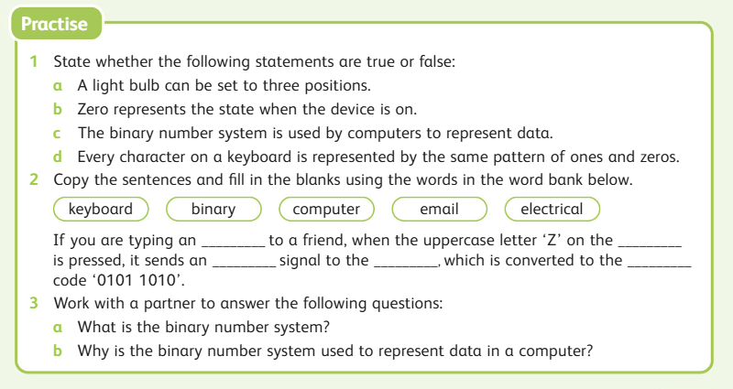

a) ___________________________________________________________________________________________________________________________________________________________________________________________________________________________________________________________________________

b) ___________________________________________________________________________________________________________________________________________________________________________________________________________________________________________________________________________