**Ans key Formal Formative 3**

**Topics: 5.4, 5.5 and 5.6**

**Total Marks: 25**

1. Here is a drawing of the solar system. /10

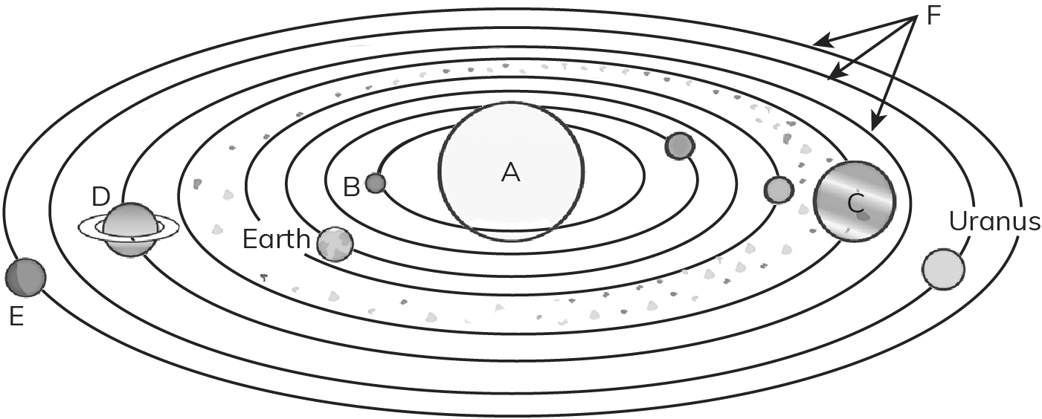

Name the bodies lettered A–E.

**G**

1. A: ________Sun______________________
2. B: _______Mercury_______________________
3. C: ________Jupiter______________________
4. D: ________Saturn______________________
5. E: _________Neptune_____________________
6. Name the lines marked F: ____Orbits________________
7. Which planet is the smallest one?

____________Mercury___________________________________________

1. What do the dots marked G on the diagram represent?

______________ASteroids__________________________________________

1. What Earth movement causes day and night?

________Earth’s spinning in its own axis/ Rotation _

1. How long does the Earth takes to complete one complete rotation in its own axis?

_____________24 hours/ 1 day

1. Complete the following sentences. Choose from the following words: /6

lengthen disappear appears towards shorten spins away from

1. The Sun ______ appears ____________ to move across the sky every day.
2. Shadows _____ shorten _____________ from early morning to midday.
3. Shadows _____ lengthen _____________ towards evening.
4. The Earth ____ spins ______________ on its axis.
5. The side of the Earth facing ____ towards ______________ the Sun has day.
6. The side of the Earth facing _____ away from _____________ the Sun has night.

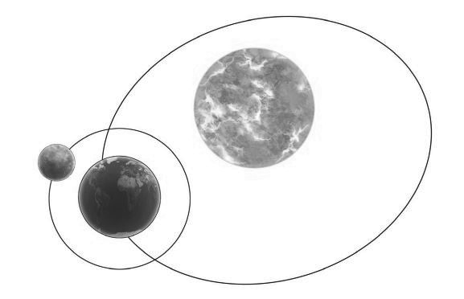

**B**

**A**

**D**

**C**

What do the letters A-D represent? /4

1. A:____Sun____________________
2. B:_____Earth___________________
3. C:_____Moon___________________
4. D______Orbit__________________
5. What is the imaginary stick passing through the Earth from the north pole to the south pole? /1

__________Axis____________________________________________________

1. Write your answer in one or two sentences. /4
2. What is an asteroid?

______It is the rocky masses that orbit the Sun which is smaller than the planets. ________________________________________________________

1. What are the celestial bodies in the solar system other than the Sun?

Planets, moons, asteroids, and comets.

_______________________________________________________________

1. How does the day and night occur?

The day and night occurs because of the rotation/ spinning of the Earth in its own axis.

1. Explain how does the length of the shadow changes from morning to evening.

The length of the shadow will decrease from morning to mid day and increase from midday towards evening.