**Station Activity**

**Station 1**

For the below mentioned question, make a neat, accurate scale drawing and answer the question. Choose an appropriate scale and mark it on your diagram.

1. Boat race takes place on a triangular course as shown. How long is the final leg?

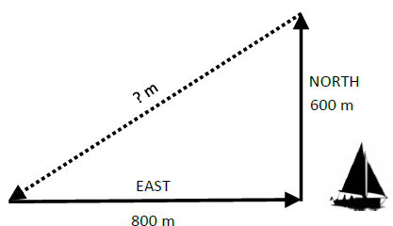

**Station 2**

A car ramp is 28 m long and makes an angle of 15° with the horizontal. A scale drawing is to be made of the ramp using a scale of 1 cm to 5 m.

a How long will the ramp be on the drawing?

b What angle will the ramp make with the horizontal on the drawing?

**Station 3**

A ladder of length 3.6 m stands on horizontal ground and leans against a vertical wall at an angle of 70° to the

horizontal (see diagram).

1. What is the size of the angle that the ladder makes with the wall (a)?
2. Draw a scale drawing using a scale of 1 cm to 50 cm, to find how far the ladder reaches up the wall (b).

