Marketing mix: Price
Price elasticity of demand
Starter activity:
Key terms | definition
Price elasticity
price elastic demand
price inelastic demand
revenue

Support notes:
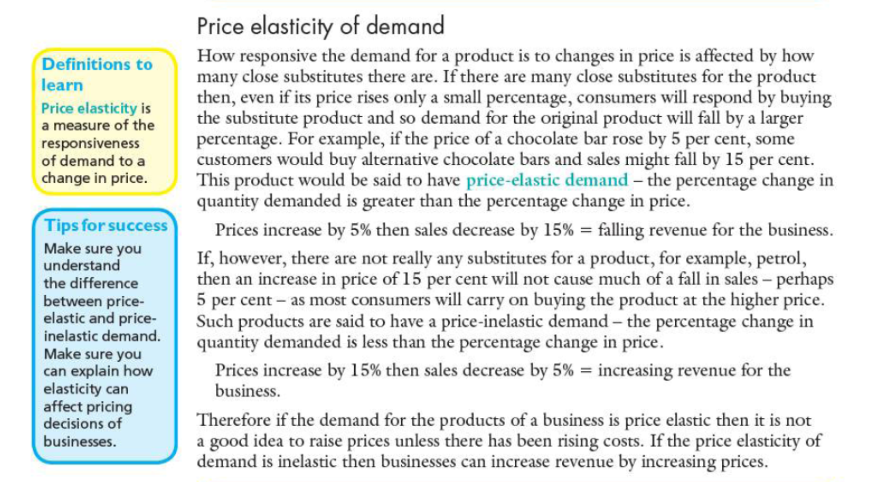

Price elasticity and its impact on price
Now that you understand different pricing strategies, we’re going to tackle one more concept that helps when selecting the right strategy: price elasticity. Elasticity helps us understand how much a change in price will affect market behaviors. If we make a small change in price, will the change have a dramatic impact on the demand for the product or only a small impact? Price elasticity is the measure of the market’s response to price changes.
Elasticity is important to pricing decisions because it helps us understand whether raising prices or lowering prices will enable us to achieve our pricing objectives. Will a discount drive increased sales? Will a price increase cause us to lose many buyers or just a few? We have to answer these questions in order to select the most effective pricing strategy.
Development activity:
















