Input and Output Devices

Question No:1

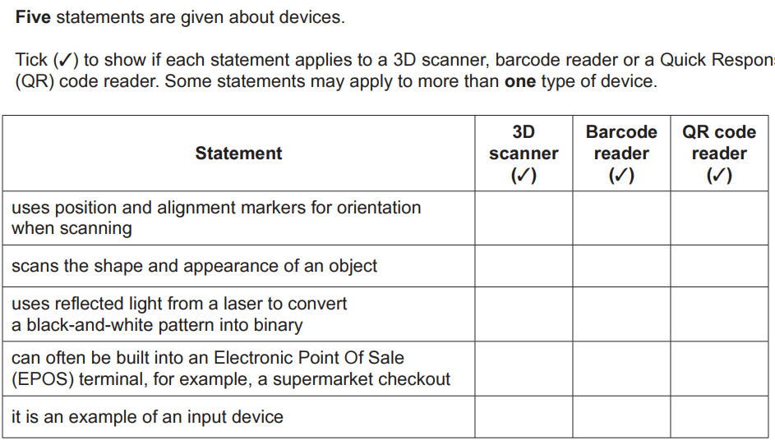

Question No:2

A supermarket uses a barcode scanner to scan the barcodes on its products.

a)Describe how the barcode scanner reads the barcode?

………………………………………………………………………………………………………………………………………………………………

………………………………………………………………………………………………………………………………………………………………

………………………………………………………………………………………………………………………………………………………………

………………………………………………………………………………………………………………………………………………………………

………………………………………………………………………………………………………………………………………………………………

………………………………………………………………………………………………………………………………………………………………

………………………………………………………………………………………………………………………………………………………………

………………………………………………………………………………………………………………………………………………………………

b)Explain how the barcode system could help the supermarket manage its stock?

………………………………………………………………………………………………………………………………………………………………

………………………………………………………………………………………………………………………………………………………………

………………………………………………………………………………………………………………………………………………………………

………………………………………………………………………………………………………………………………………………………………

………………………………………………………………………………………………………………………………………………………………

………………………………………………………………………………………………………………………………………………………………

………………………………………………………………………………………………………………………………………………………………

………………………………………………………………………………………………………………………………………………………………

Question No:3

Ron is attending a music concert. He has bought three tickets. Each ticket number is displayed as a hexadecimal number.

a) Each ticket also has a QR code. The QR code is scanned at the entrance to the venue.

A person can only enter the venue with a valid QR code that allows entry.

When a person enters, a count is incremented to show how many people have entered the

venue.

Explain how the system scans the QR code, checks if a person can enter and counts how

many people have entered.

………………………………………………………………………………………………………………………………………………………………

………………………………………………………………………………………………………………………………………………………………

………………………………………………………………………………………………………………………………………………………………

………………………………………………………………………………………………………………………………………………………………

………………………………………………………………………………………………………………………………………………………………

………………………………………………………………………………………………………………………………………………………………

………………………………………………………………………………………………………………………………………………………………