*You are going to edit a spreadsheet to calculate profit and loss for the Alinao Beach and Dive Resort. Alinao’s financial year is split into four quarters. Each quarter has three months. All currency values must be in dollars to 0 decimal places.*

1. Open and examine the file **2032-summary.csv** in a spreadsheet package.

In the header enter and centre align the text:

**Edited by:** followed by a space, your name, centre number and candidate number.

In the footer enter and centre align the text:

**Edited on:** followed by a space, today’s automated date, a space then the text at followed by a space then the automated time.

Save this as a spreadsheet with the file name **Summary_** followed by your centre number and candidate number. For example, Summary_ZZ999_9999 [4]

1. Format the spreadsheet to look like this:

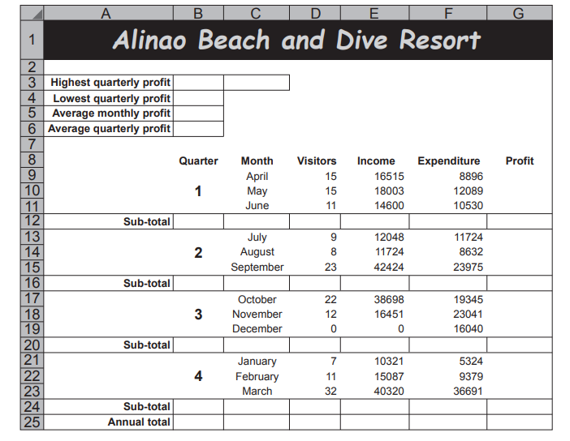

Format the merged cell in row 1 to contain orange text, font size 24, on a black background. The text in this cell should contrast with the background when printed in black and white.

Format the text in the merged cells in column B to be font size 20. [11]

1. In cell D12 use a function to calculate the total number of visitors for April, May and June. [1]
2. In cell E12 use a function to calculate the total income for April, May and June. [1]
3. In cell F12 use a function to calculate the total expenditure for April, May and June. [1]
4. Replicate the formulae entered in steps 15 to 17 to calculate the sub-totals for all other quarters.[1]
5. Calculate the profit for each month and each quarter. Profit = Income – Expenditure [2]
6. Calculate, in appropriate cells, the total number of visitors, the total income, the total expenditure and the total profit for the year. [1]
7. Format cell G9 to have a red background with white text, only if the value in the cell is negative. Apply this formatting to cells B3 to B6 and to all other cells containing numeric values in column G. [4]

**EVIDENCE 1**

Place in your Evidence Document a screenshot that shows how you applied the formatting to cell G9.

1. In cell B3 use a function to display the highest profit for any quarter. [2]
2. In cell B4 use a function to display the lowest profit for any quarter. [1]
3. In cell B5 use a function to display the average monthly profit. [2]
4. In cell B6 use a function to display the average quarterly profit. [1]
5. Format all currency values in dollars with 0 decimal places. [1]
6. In cell C3 use a formula to display the number of the quarter which made the highest quarterly profit. The number of each quarter is displayed in column B.
7. Save your spreadsheet

Print your spreadsheet showing the formulae.

Make sure:

• it is in landscape orientation

• the row and column headings are displayed

• the contents of all cells are fully visible and can be easily read. [2]

**PRINTOUT 1**

Make sure that you have entered your name, centre number and candidate number on your spreadsheet showing the formulae.

1. Print your spreadsheet showing the values.

Make sure the:

• printout fits on a single page

• row and column headings are not displayed

• contents of these cells are fully visible and can be easily read. [1]

**PRINTOUT 2**

Make sure that you have entered your name, centre number and candidate number on your spreadsheet showing the values.