TERM 1 Revision MARKING SCHEME
YEAR 8 - CS
1(a) i | Sound | 1
1 a (ii) | Lossy compressed file | 1
1 b | Computer consist of transistors / logic circuits/gates …  … that can only store/process data in two states / high-low / on-off / 1 and 0 | 2
1 c | 01000000  01100101  11110010 | 3
1 d | 0100 (1 mark) 0010 (1 mark)  1100 (1 mark) 1110 (1 mark) | 4
1 e | Two marks for two correct stages of working, one mark for correct final answer  • 100 × 150  • 15 000 × 16 // 15 000 × 2  • 240 000 / 8  • 30 000 bytes | 3
1 f | One mark for full method of working e.g. conversion to binary then flipping and adding 1 One mark for correct answer  • 10110010 | 2
1 g | 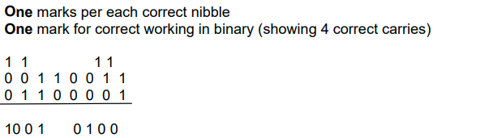 | 3
1 h | Two from:  • The result of the calculation is greater than 255 // The value generated is larger than can be stored in the register  • The result of the calculation would require more than 8 bits to be represented // A register has a predetermined number of bits and there are too many bits for it | 2
2 a | One mark for each correct definition:  • The sample rate is the number of samples taken in a second/per time unit  • The sample resolution is the number of bits per sample | 2
2 b | Lossy compression | 1
2 c (i) | Any two from: e.g.  • Destination/receivers (IP) address  • Packet number  • Originator’s/senders (IP) address | 2
2 c (ii) | Any five from:  • Data is broken/split/divided into packets  • Each packet (could) take a different route  • A router controls the route/path a packet takes  • … selecting the shortest/fastest available route/path  • Packets may arrive out of order  • Once the last packet has arrived, packets are reordered  • If a packet is missing/corrupted, it is requested again | 5
3a | One mark per each correct character in the correct order:  • 9  • 3  • 0  • D | 4
3b(i) | 00001111 | 1
3b(ii) | Any one from:  • The value becomes incorrect/inaccurate as the right most bits are lost  • It is divided by 8 | 1
3c | Any two from:  • Easier/quicker to understand/read/write  • Easier/quicker to debug  • Less likely to make a mistake  • Shorter representation // Takes up less screen space | 2
3d | One mark for two correct characters, two marks for three correct characters in the correct order:  • 1  • 2  • D | 2
4 a | Any three from:  • A character set is used  • … such as Unicode/ASCII  • Each character has a unique binary value | 3
4 b (i) | It reduces the file size | 1
4 b (ii) | Any four from:  • A compression algorithm is used  • … such as RLE/run length encoding  • Repeating words/characters/phrases are identified // Patterns are identified  • … and indexed  • … with number of occurrences  • … with their position | 4
4 b (iii) | Any two from: e.g.  • To save storage space  • To make it quicker to transmit  • To make it small enough to attach to an email  • To reduce the bandwidth needed to transmit | 2
5 | 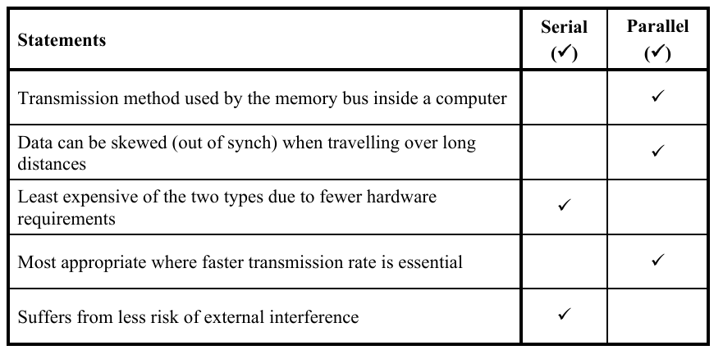 | 5
6 a | Initializing Total Variable 1  FOR Loop Structure 1  Input within Loop 1  Accumulating Total 1  Outputting the Result 1  pseudocode  total <- 0  FOR i <- 1 TO 10  OUTPUT "Enter a number: ", number  total <- total + number  NEXT i  OUTPUT "The total is: ", total  Python code  total = 0  for i in range(10):  number = int(input("Enter a number: "))  total = total + number  print("The total is:", total) | 5
6 b | 1 mark for each correct circle  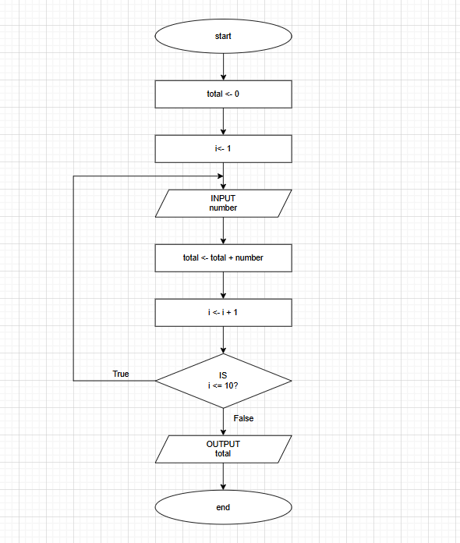 | 5
7 | One mark per mark point  MP1 Correct input statement with appropriate variable  MP2 Elements of selection statement present – CASE OF ENDCASE  MP3 At least one correct branch in the case statement  MP4 All branches from 1 to 3 correct  MP5 Correct use of OTHERWISE with correct output.  For example:  INPUT Number  CASE OF Number  1 : OUTPUT Number  2 : OUTPUT Number  3 : OUTPUT Number  OTHERWISE OUTPUT "ERROR"  ENDCASE  Or  INPUT Number  CASE OF Number  1 : OUTPUT 1  2 : OUTPUT 2  3 : OUTPUT 3  OTHERWISE OUTPUT "ERROR"  ENDCASE | 5
8 | 1 mark for CASE OF  1 mark for correct case statement  1 mark for OTHERWISE  1 mark for endcase  CASE OF variable  CASE 1: statement  CASE 2: statement  OTHERWISE statement  ENDCASE | 4

