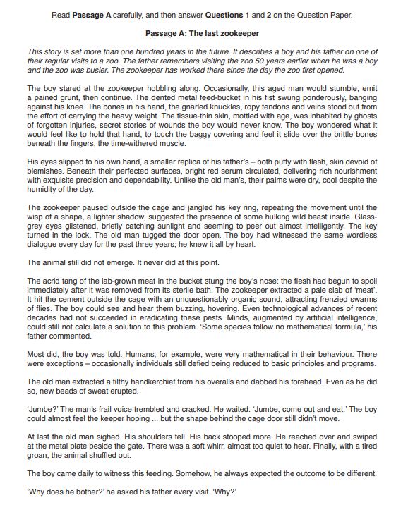

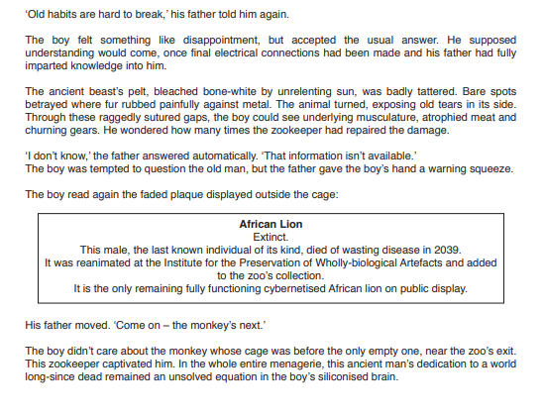

**Imagine you are a zookeeper. Later that evening you write in your journal reflecting on your thoughts and feelings about your life now and how things have changed. Write your journal. In your journal you should include:**

* **describe what you have to do each day, why you do it and how that makes you feel**
* **explain what you have noticed about the boy and his father and your feelings about each of them**
* **consider how things have changed for you and the world around you since you first started working at the zoo and suggest what you think the future may hold for you.**

**Base your passage on what you have read in Passage A, but be careful to use your own words. Address each of the three bullet points.**

**Begin your journal, ‘Today was…’**

**Write about 250 to 350 words.**

**List Down the Main points for each bullet point**

……………………………………………………………………………………………………………………………………………………………………………………………………………………………………………………………………………………………………………………………………………………………………………………………………………………………………………………………………………………………………………………………………………………………………………………………………………………………………………………………………………………………………………………………………………………………………………………………………………………………………………………………………………………………………………………………………………………………………………………………………………………………………………………………………………………………………………………………………………………………………………………………………………………………………………………………………………………………………………………………………………………………………………………………………………………………………………………………………………………………………………………………………………………………………………………………………………………………………………………………………………………………………………………………………………………………………………………………………………………………………………………………………………………………………………………………………………………………………………………………………………………………………………………………………………………………………………………………………………………………………………………………………………………………………………………………………………………………………………………………………………………………………………………………………………………………………………………………………………………………………………………………………………………………………………………………………………………………………………………………………………………………………………………………………………………………………………………………………………………………………………………………………………………………………………………………………………………………………………………………………………………………………………………………………………………………………………………………………………………………………………………………………………………………………………………………………………………………………………………………………………………………………………………………………………………………………………………………………………………………………………………………………………………………………………………………………………………………………………………………………………………………………………………………………………………………………………………………………………………………………………………………………………………………………………………………………………………………………………………………………………………………………………………………………………………………………………………………………………………………………………………………………………………………………………………………………………………………………………………………………………………………………………………………………………………………………………………………………………………………………………………………………………………………………………………………………………………………………………………………………………………………………………………………………………………………………………………………………………………………………………………………………………………………………………………………………………………………………………………………………………………………………………………………………………………………………………………………………………………………………………………………………………………………………………………………………………………………………………………………………………………………………………………………………………………………………………………………………………………………………………………………………………………………………………………………………………………………………………………………………………………………………………………………………………………………………………………………………………………………………………………………………………………………………………………………………………………………………………………………………………………………………………………………………………………………………………………………………………………………………………………………………………………….

………………………………………………………………………………………………………………………………………………………………………………………………………………………………………………………………………………………………………………………………………………………………………………………………………………………………………………………………………………………………………………………………………………………………………………………………………………………………………………………………………………………………………………………………………………………………………………………………………………………………………………………………………………………………………………………………………………………………………………………………………………………………………………………………………………………………………………………………………………………………………………………………………………………………………………………………………………………………………………………………………………………………………………………………………………………………………………………………………………………………………………………………………………………………………………………………………………………………………………………………………………………………………………………………………………………………………………………………………………………………………………………………………………………………………………………………………………………………………………………………………………………………………………………………………………………………………………………………………………………………………………………………………………………………………………………………………………………………………………………………………………………………………………………………………………………………………………………………………………………………………………………………………………………………………………………………………………………………………………………………………………………………………………………………………………………………………………………………………………………………………………………………………………………………………………………………………………………………………………………………………………………………………………………………………………………………………………………………………………………………………………………………………………………………………………………………………………………………………………………………………………………………………………………………………………………………………………………………………………………………………………………………………………………………………………………………………………………………………………………………………………………………………………………………………………………………………………………………………………………………………………………………………………………………………………………………………………………………………………………………………………………………………………………………………………………………………………………………………………………………………………………………………………………………………………………………………………………………………………………………………………………………………………………………………………………………………………………………………………………………………………………………………………………………………………………………………………………………………………………………………………………………………………………………………………………………………………………………………………………………………………………………………………………………………………………………………………………………………………………………………………………………………………………………………………………………………………………………………………………………………………………………………………………………………………………………………………………………………………………………………………………………………………………………………………………………………………………………………………………………………………………………………………………………………………………………………………………………………………………………………………………………………………………………………………………………………………………………………………………………………………………………………………………………………………………………………………………………………………………………………………………………………………