1) Write a program in scratch to match the following algorithm.

|  |  |
| --- | --- |
| **STEP** | **INSTRUCTION** |
| 1 | When the green flag is clicked |
| 2 | Set position to x = 120 , y = 50 |
| 3 | Set pen colour to 30 |
| 4 | Pen Down |
| 5 | Move 5 steps |
| 6 | Turn right 36 degrees |
| 7 | Repeat steps three and four 10 times |
| 8 | Pen up |
| 9 | Stop program |

1. Open Scratch.
2. Write a program in scratch using appropriate blocks.
3. Follow the sequence of block.
4. Save your Scratch Program with your name - Class.

|  |  |  |  |
| --- | --- | --- | --- |
| **RUBRIC FOR SCRATCH PROGRAM.** | | | |
|  | 1 | 2 | 3 |
| Able to insert spreadsheet |  |  |  |
| Able to identify data type |  |  |  |
| Able to insert chart in excel |  |  |  |
| Able to Save |  |  |  |
| **Key**:   1. Needs more opportunity to develop this skill. 2. Beginning to demonstrate this skill. 3. Has achieved this skill. | | | |

3) Write an algorithm for given Scratch program.

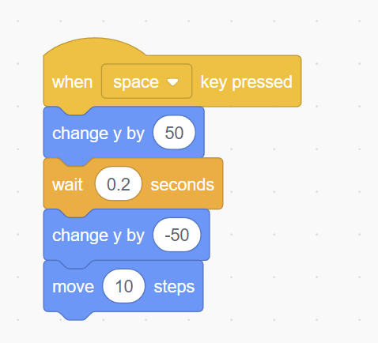

___________________________________________________________________________________________________________________________________________________________________________________________________________________________________________________________________________________________________________________________________________________________________________________________________________________________________________________________________________________________________________________________________________________________________________________________________________________

4) Create a table as follows :

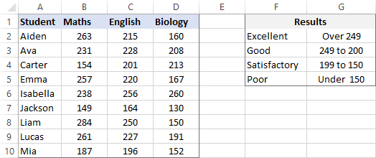

1. Open MS Excel.
2. Create above spreadsheet in excel.
3. Which type of data is seen in the table? _____________________
4. Insert the best suitable chart that fits to this data.
5. Save your document as Yourname-Class.

|  |  |  |  |
| --- | --- | --- | --- |
| **RUBRIC FOR CREATING SPREADSHEET AND INSERTING CHART.** | | | |
|  | 1 | 2 | 3 |
| Able to insert spreadsheet |  |  |  |
| Able to identify data type |  |  |  |
| Able to insert chart in excel |  |  |  |
| Able to Save |  |  |  |
| **Key**:   1. Needs more opportunity to develop this skill. 2. Beginning to demonstrate this skill. 3. Has achieved this skill. | | | |