ICT –Term 1 Revision- MARK SCHEME
Question | Answer | Marks
1 | 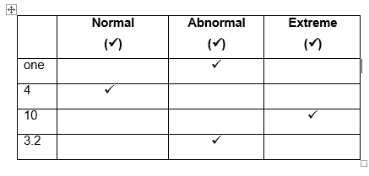  4 correct answers 3 marks  2 or 3 correct answers 2 marks  1 correct answer 1 mark | 3
2. | 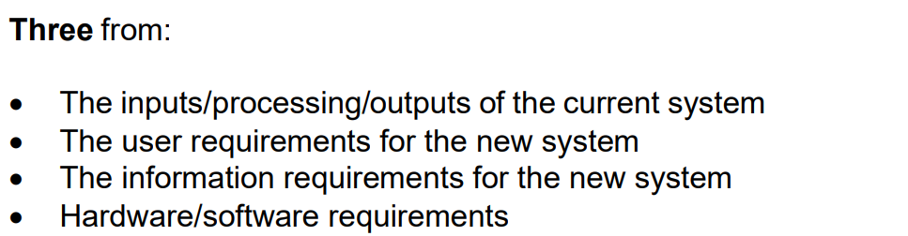 | 3
3 | Any Two From  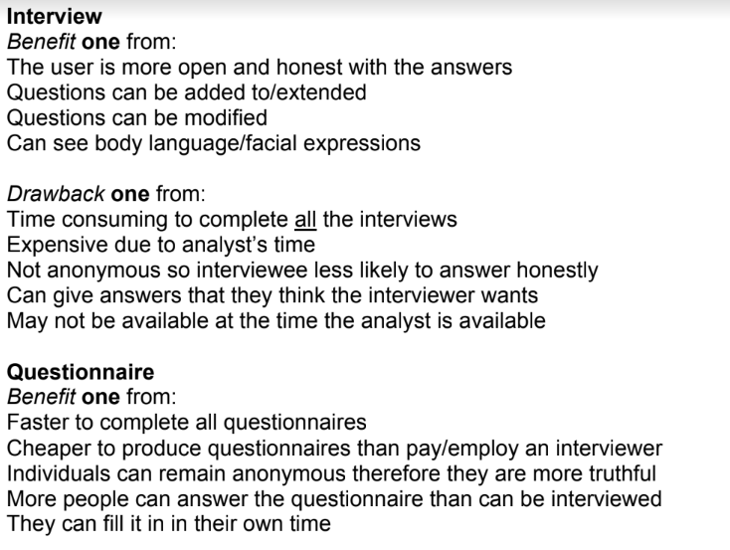  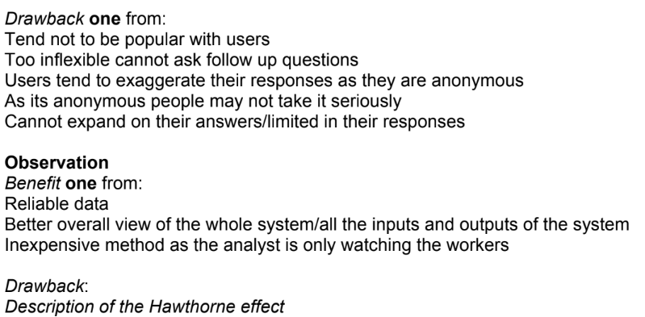 | 6
4.a |  | 1
4.b | 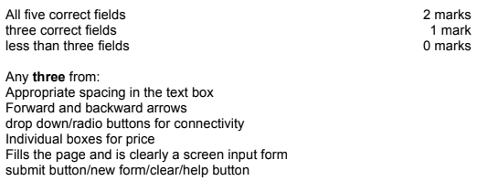 | 5
5 | 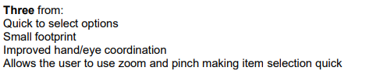 | 3
6 | 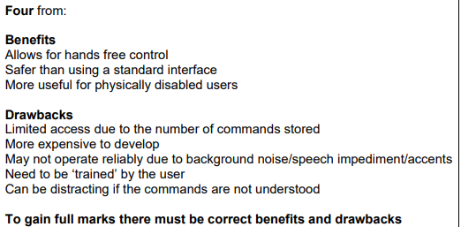 | 4
7 | 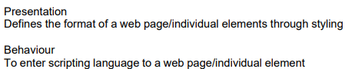 | 4

