**Chapter 3: Opportunities, risk , legal and ethical considerations**

**Topic: ethical considerations**

**Starter activity:**

|  |  |
| --- | --- |
| **Key terms** | **definition** |
| ethical |  |
| Corporate social responsibility |  |
| Pressure groups |  |

Make notes of key points from the reading resources about unethical business practices:

**……………………………………………………………………………………………………………………………………………………………….**

**……………………………………………………………………………………………………………………………………………………………….**

**……………………………………………………………………………………………………………………………………………………………….**

**……………………………………………………………………………………………………………………………………………………………….**

**……………………………………………………………………………………………………………………………………………………………….**

**……………………………………………………………………………………………………………………………………………………………….**

**……………………………………………………………………………………………………………………………………………………………….**

**……………………………………………………………………………………………………………………………………………………………….**

**……………………………………………………………………………………………………………………………………………………………….**

**……………………………………………………………………………………………………………………………………………………………….**

**……………………………………………………………………………………………………………………………………………………………….**

**Development activity:**

**Answer to case study given in resource book page 74.**

**……………………………………………………………………………………………………………………………………………………………….**

**……………………………………………………………………………………………………………………………………………………………….**

**……………………………………………………………………………………………………………………………………………………………….**

**……………………………………………………………………………………………………………………………………………………………….**

**……………………………………………………………………………………………………………………………………………………………….**

**……………………………………………………………………………………………………………………………………………………………….**

**……………………………………………………………………………………………………………………………………………………………….**

**……………………………………………………………………………………………………………………………………………………………….**

**……………………………………………………………………………………………………………………………………………………………….**

**……………………………………………………………………………………………………………………………………………………………….**

**……………………………………………………………………………………………………………………………………………………………….**

**Support notes:**

**Ethical considerations and their impact on businesses**

Ethics relate to principles, standards of behaviour and ‘doing the right thing’. An ethical business will act in a socially responsible way, doing what is right, even if it is not required to do so by legislation or in order to maximise profit.

Most business activity involves workers, suppliers and customers. The way that a business treats these three groups of stakeholders is a good sign of how ethical it is.

**Treating workers ethically**

Examples include:

* paying a fair wage
* providing good working conditions
* allowing flexible working

**Treating suppliers ethically**

* paying fair prices
* having reasonable expectations
* paying bills on time

**Treating customers ethically**

Examples include:

* Exceeding customers’ expectations - this can include offering excellent customer service, quality products or services, and making the customer feel valued and appreciated.
* Only providing what customers want – ensuring that the business meets the needs of the customer rather than selling extra products or services just to meet profit targets. For example, not selling a customer a mobile phone contract that they will not use.
* Giving clear and accurate product and service information to allow customers to make informed decisions.

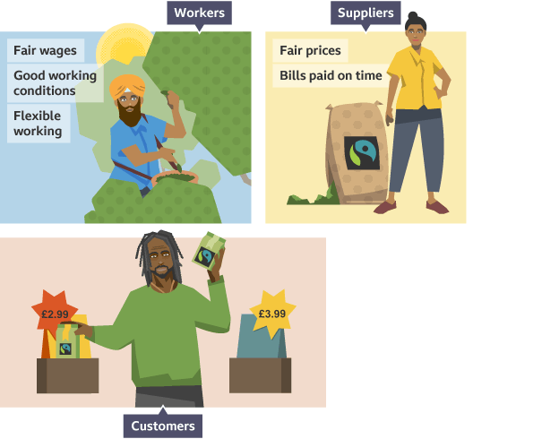

**Sourcing of materials**

Sourcing supplies ethically usually involves ensuring that suppliers and their workers are treated fairly, and paid a reasonable price for the work that they do. Ethically sourced supplies are often more expensive, so buying them is usually a deliberate business decision because it could make a business less competitive, leading to lower sales and reduced profit margins. In addition, businesses will usually need to put in place checks to ensure that their suppliers are themselves acting ethically. This will also incur additional costs.

**Marketing decisions**

Businesses that behave ethically can benefit from good publicity, which is likely to attract customers and increase sales. For example, businesses that have signed up to the Ethical Trading Initiative can show that they have taken steps to address the use of child labour in the production of the goods they sell.

Those businesses that do not behave in an ethical way are more likely to receive bad publicity and get a poor reputation. For example, retailers that buy from suppliers that use child labour to produce goods may be targeted by negative articles in the media, undoing much of their own marketing activity.

Any business activity will have an impact upon the environment, either through the natural resources that it uses or the waste products that it produces.

A business can carry out a green audit in order to measure the environmental impact of its activities. For example, this may involve measuring its carbon footprint. The four main environmental issues that are most likely to influence the activities of a business are sustainability, waste disposal, pollution and climate change.

**Sustainability**

Working in a sustainable way means that business activity does not use up or destroy natural resources. To achieve this, a business may use renewable energy, recycle materials such as paper and ink cartridges, or use devices that save energy and water.

**Waste disposal**

Traditionally, waste has either been incinerated or sent to landfill sites. However, these are not environmentally friendly ways of dealing with waste. Instead, businesses can reduce the amount of waste that they produce, which reduces costs and means that there is less waste to dispose of. Many businesses also look for ways in which waste materials can be reused.

**Pollution**

Pollution commonly refers to the contamination of air or water with harmful chemicals. Air pollution can cause a number of health-related issues, and animals and plants that live in seas and rivers are affected by water pollution. Business activity may also cause disturbance through noise pollution.

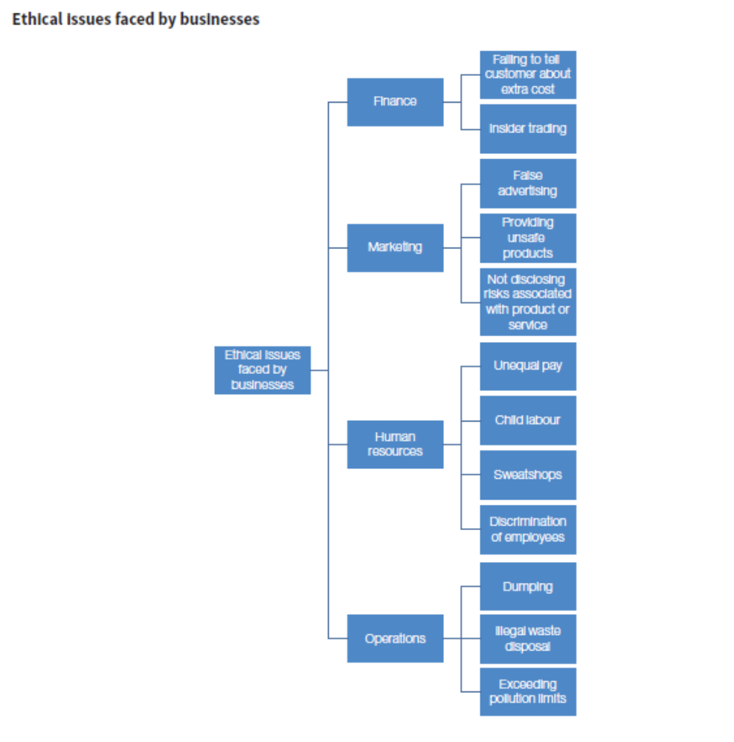

**Practice Activity:**

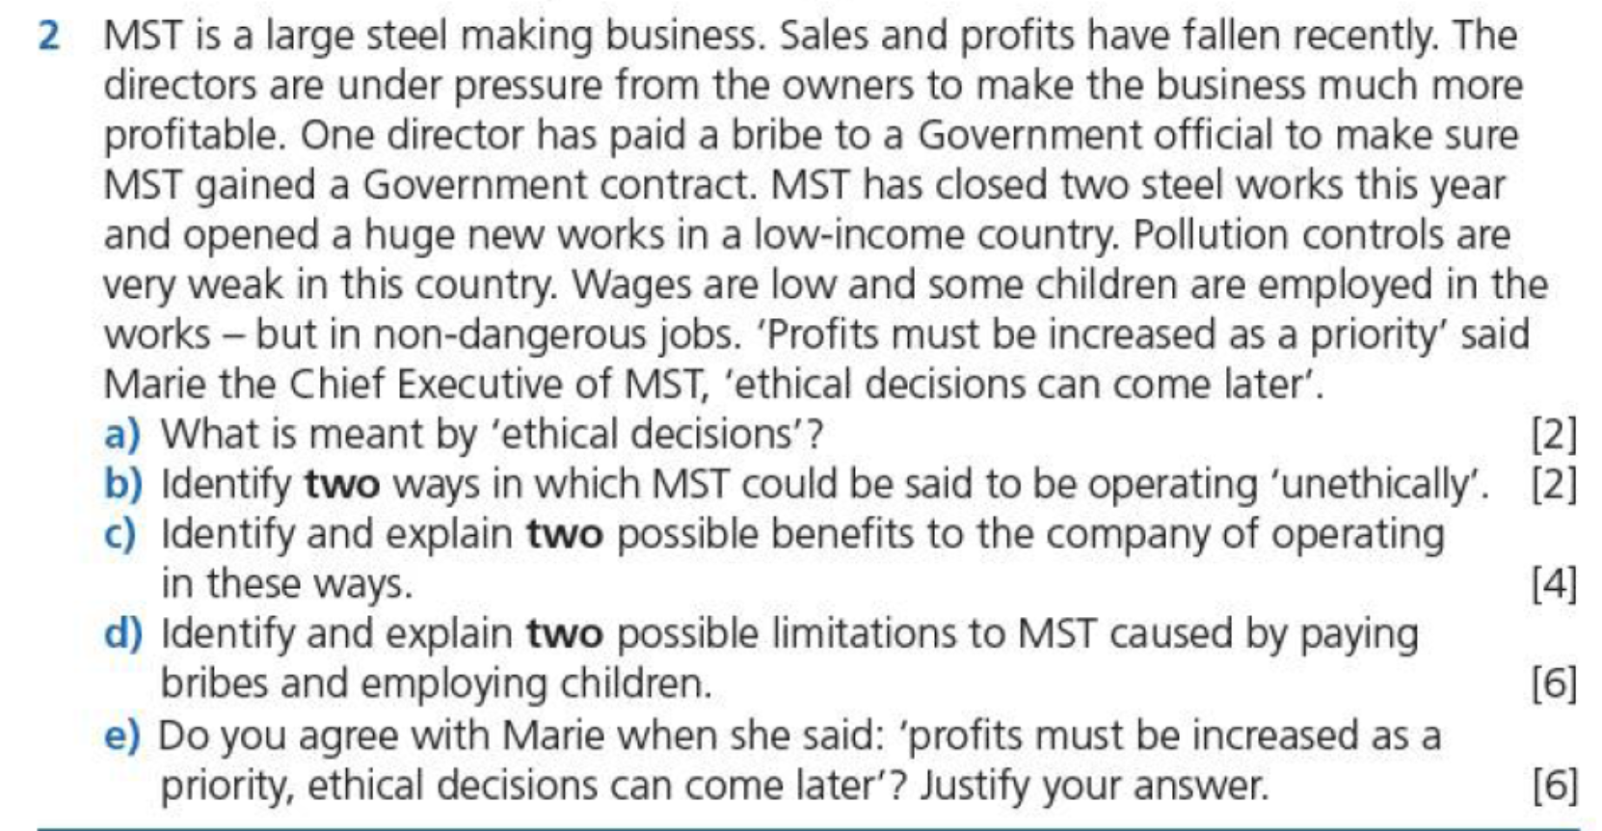

**……………………………………………………………………………………………………………………………………………………………….**

**……………………………………………………………………………………………………………………………………………………………….**

**……………………………………………………………………………………………………………………………………………………………….**

**……………………………………………………………………………………………………………………………………………………………….**

**……………………………………………………………………………………………………………………………………………………………….**

**……………………………………………………………………………………………………………………………………………………………….**

**……………………………………………………………………………………………………………………………………………………………….**

**……………………………………………………………………………………………………………………………………………………………….**

**……………………………………………………………………………………………………………………………………………………………….**

**……………………………………………………………………………………………………………………………………………………………….**

**……………………………………………………………………………………………………………………………………………………………….**

**……………………………………………………………………………………………………………………………………………………………….**

**……………………………………………………………………………………………………………………………………………………………….**

**……………………………………………………………………………………………………………………………………………………………….**

**……………………………………………………………………………………………………………………………………………………………….**

**……………………………………………………………………………………………………………………………………………………………….**

**……………………………………………………………………………………………………………………………………………………………….**

**……………………………………………………………………………………………………………………………………………………………….**

**……………………………………………………………………………………………………………………………………………………………….**

**……………………………………………………………………………………………………………………………………………………………….**

**……………………………………………………………………………………………………………………………………………………………….**

**……………………………………………………………………………………………………………………………………………………………….**

**……………………………………………………………………………………………………………………………………………………………….**

**……………………………………………………………………………………………………………………………………………………………….**

**……………………………………………………………………………………………………………………………………………………………….**

**……………………………………………………………………………………………………………………………………………………………….**

**……………………………………………………………………………………………………………………………………………………………….**

**……………………………………………………………………………………………………………………………………………………………….**

**……………………………………………………………………………………………………………………………………………………………….**

**……………………………………………………………………………………………………………………………………………………………….**

**……………………………………………………………………………………………………………………………………………………………….**

**……………………………………………………………………………………………………………………………………………………………….**

**……………………………………………………………………………………………………………………………………………………………….**

**Homework/Extension task: My values shape my identity (answer the question below with reference to Qatar)**





























