***Making pages for a Class Big Book of Dinosaurs***

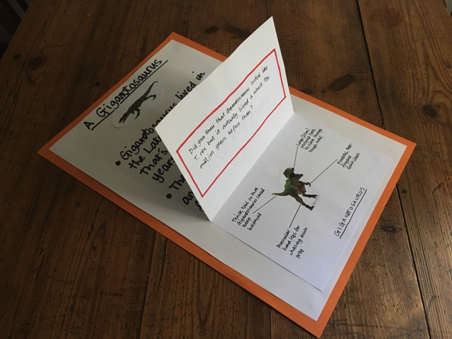

***Per child you will need:***

* *A sheet of A3 white paper, slightly trimmed so that it can be mounted on an A3 page in the Big Book.*
* *A sheet of A4 white paper*

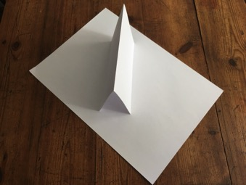

* *At least two small drawings or photographs of each child’s chosen dinosaur. One of these can go at the top of their page while the other will be used for the labelled image under the ‘fantastic fact’ flap, as discussed in the Plan.*

***For the Book itself you will need:***

* *A simple A3 scrapbook into which individual pages can be stuck. These are inexpensive and easy to find.*

***Writing:***

* *Children write their dinosaur’s name at the top of the page and add one of the small photographs or a drawing of their own to the title.*
* *To complete the labelled image section of their writing, children use the A4 sheet, folded in half horizontally to create the ‘fantastic fact’ flap.*
* *On the inside bottom half of the flap they glue down their other dinosaur drawing or photograph and add labels.*
* *On the outside of the flap they create a title for their ‘fantastic fact’ – That’s Amazing! Lift and Learn, etc.*
* *Under the flap and above their labelled image they write out their chosen ‘fantastic fact’.*
* *When the flap is entirely finished it can be stuck down onto the main page, leaving enough space above for children to write their main facts about their dinosaur.*
* *For these main facts, teachers can either get children to write direct on to the page or can provide lined paper which is then trimmed to fit onto the page once the writing is complete. The advantage of this latter approach is that children can create a first draft before then transcribing it onto the main page as a ‘best copy’. Additional information can go on the reverse of the page in the Big Book.*

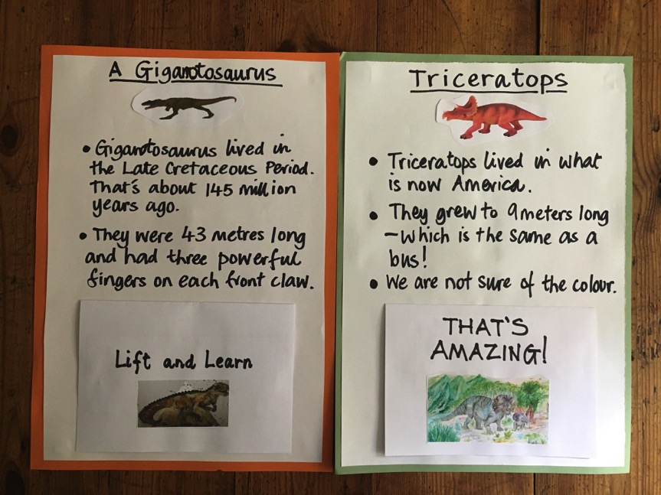

Unit 5 Days 2-4

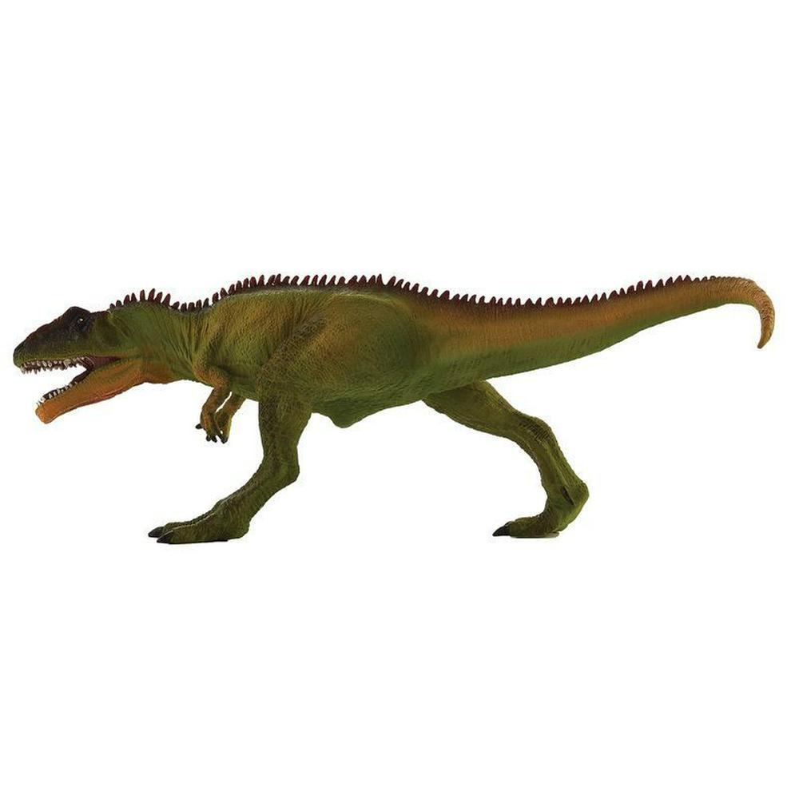  
Unit 5 Day 2