**4. Algorithm design and problem-solving**

**(a)** 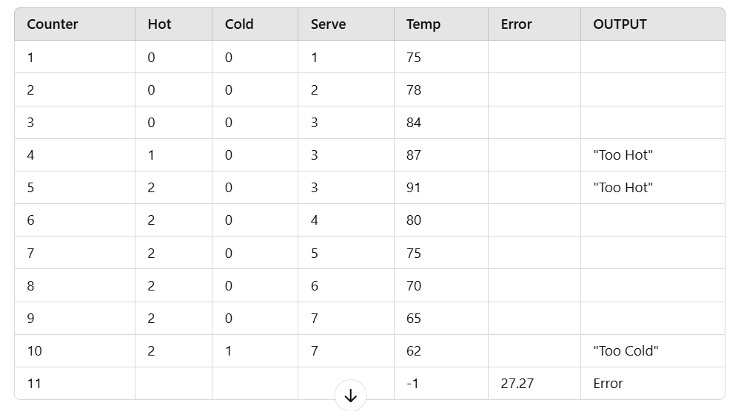

(b) The process of calculating error.

(c) The purpose of the algorithm is to input temperature and printing the output “Too Hot” or “Too Cold” after checking the conditions.