MS-WORD

Microsoft Word is a word processor developed by Microsoft. It was first

released in 1983 under the name Multi-Tool Word for Xenix systems. MS

Word is a popular word-processing program used primarily for creating

documents such as letters, brochures, learning activities, tests, quizzes and

students' homework assignments. There are many simple but useful features

available in Microsoft Word to make it easier for study and work. That's why

so many people would prefer to convert the read-only PDF to editable Word

and edit PDF in Word.

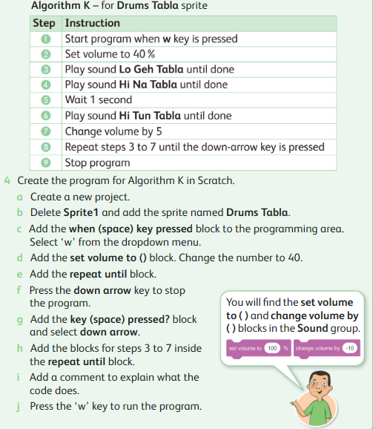I) Create the Scratch 3 program using conditional control loop.

|  |  |  |  |  |
| --- | --- | --- | --- | --- |
| **Rubric for Scratch 3 program** | | | | |
|  | 1 | 2 | 3 | Total |
| Able to add sprite |  |  |  |  |
| Able to use repeat until |  |  |  |  |
| Able to run the program |  |  |  |  |
| **Key**:1. Needs more opportunity to develop this skill.  2.Beginning to demonstrate this skill.  3.Has achieved this skill. | | | | |