**Worksheet**

**Topic: Data Transmission**

1. Data packets also have a payload and a trailer. Explain these two terms.

payload:

...........................................................................................................................................

trailer:

...........................................................................................................................................

2. 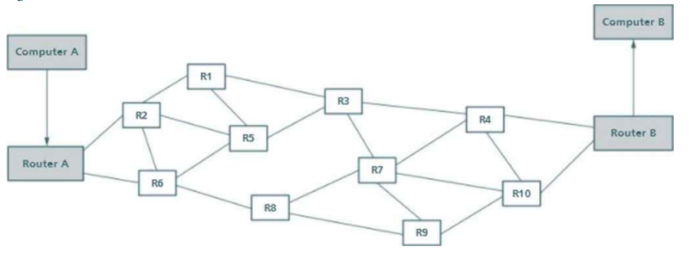

Using the above diagram, explain how packet switching works when sending a 500 KiB file from computer 'A' to computer 'B'.

...........................................................................................................................................

...........................................................................................................................................

...........................................................................................................................................

...........................................................................................................................................

...........................................................................................................................................

3. Give three disadvantages of using packet switching

...........................................................................................................................................

...........................................................................................................................................

...........................................................................................................................................

...........................................................................................................................................

...........................................................................................................................................

...........................................................................................................................................

4. The data is sent using parallel half-duplex data transmission.

(a) Describe how data is sent using parallel half-duplex data transmission

...........................................................................................................................................

...........................................................................................................................................

...........................................................................................................................................

...........................................................................................................................................

...........................................................................................................................................

...........................................................................................................................................

(b) State two drawbacks of using parallel data transmission.

Drawback 1 .......................................................................................................................

...........................................................................................................................................

Drawback 2 .......................................................................................................................

...........................................................................................................................................