**Quiz 3 Chapter 8**

**(Graded)**

1. The company has a website which uses a digital certificate.

Explain the purpose of digital certificate

…………………………………………………………………………………………………………………………………………………………………………………………………………………[1]

2. A digital certificate is attached to an email

State three items contained in a digital certificate

1…………………………………………………………………………………………………………

2…………………………………………………………………………………………………………

3………………………………………………………………………………………………………[3]

1. Email is a service provided by the internet. For each of the following problems, associated with email, describe methods of protecting your data.
2. Spam

……………………………………………………………………………………………………………………………………………………………………………………………………………………………………………………………………………………………………………………………………………………………………………………………………………………………………………………………………………………………………………………...[2]

1. Viruses

……………………………………………………………………………………………………………………………………………………………………………………………………………………………………………………………………………………………………………………………………………………………………………………………………………………………………………………………………………………………………………………………………..[2]

1. There are a number of health and safety issues associated with the use of computers. Draw arrows from the terms Health or Safety to the matching issue. Use a maximum of four arrows.

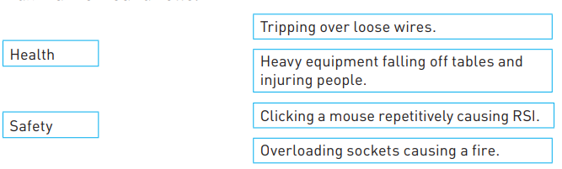

[2]