***Quiz no :3 Marks /20***

5 marks

1. Apply tanween according to the end sound:

\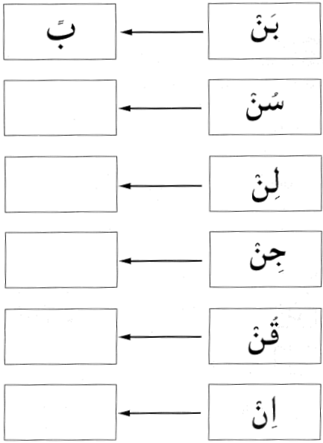

1. Colour the heavy letters: 7 marks

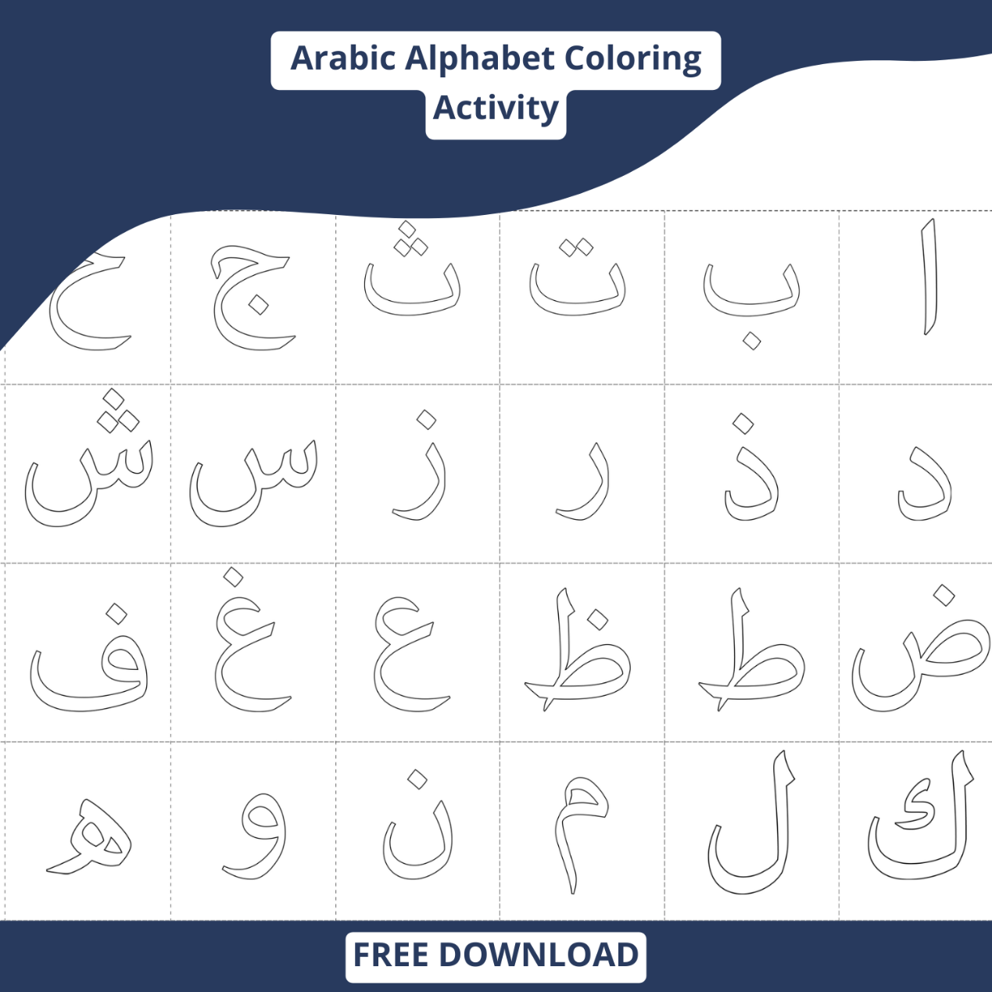

1. Choose the correct answer:
2. When you want something from Allah we ask _____________.
3. Dua b. sleep c. cry
4. When you have two haraka it’s called_________________,
5. Fatha b. tanween c. sukun
6. The tanween letters end with _____________ sound.

a. Noon b. thaa c. haa

1. Heavy letters are pronounced with _________________.

a. throat b. nose c. full mouth

1. ق with dhammahtein is called _______________ .
2. Kin b. kun c. kan
3. Write any 3 heavy letters: