**Security of data (Marking Scheme)**

1. Hacking

Phishing

Smishing

Pharming

Spyware/Key logging

Virus

[6]

1. a [2]

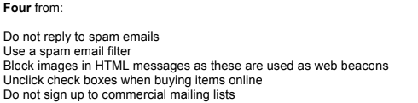

**b** [2]

