**Warm up Activity: Bugs in Computer Games - Testing Programs**

**Title: Frog Jumping Program**

**Instructions:**

1. Select a Background:

- Choose a background image for your program environment.

2. Select a Frog Character:

- Choose a Frog character sprite to represent your jumping frog.

3. Add the Blocks of Code:

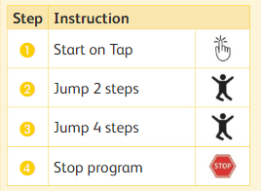 

4. Test the Code:

- Tap the Frog character to test the code.

- Observe the Frog's behavior and ensure it jumps 2 steps and then 4 steps as expected.

5. Conclusion:

- Reflect on any bugs or errors encountered and how you resolved them.

- Discuss your experience with testing and debugging the program.

**Main Activity:** Frog's New Moves

1. Open the game in the beginning activity.

2. Here is a new algorithm for the Frog. This is the new result we want in the game.

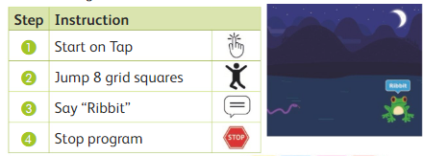

3. Here is the new code for the Frog:



4. Change your program to the new code for the Frog. Test this code.

6. Select a Snake character.

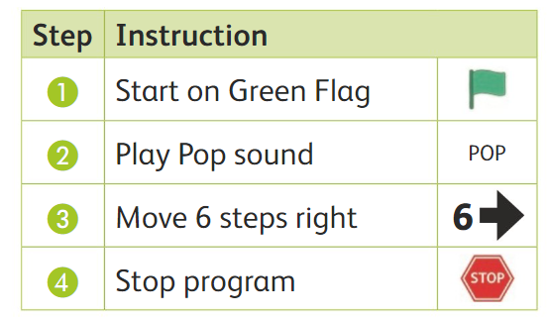

7. Create the code to match the algorithm.

8. Test your program. Did you get the right result?_____________