1. Describe the stages in the preparation of a sample of copper sulfate crystals using the following **equipment.**

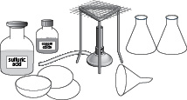

…………………………………………………………………………………………………………………………………………………………………………

…………………………………………………………………………………………………………………………………………………………………………

…………………………………………………………………………………………………………………………………………………………………………

…………………………………………………………………………………………………………………………………………………………………………

…………………………………………………………………………………………………………………………………………………………………………

…………………………………………………………………………………………………………………………………………………………………………

…………………………………………………………………………………………………………………………………………………………………………

…………………………………………………………………………………………………………………………………………………………………………

…………………………………………………………………………………………………………………………………………………………………………

…………………………………………………………………………………………………………………………………………………………………………

…………………………………………………………………………………………………………………………………………………………………………

…………………………………………………………………………………………………………………………………………………………………………

………………………………………………………………………………………………………………………………………………………….…………[5]