**The Sparrow**

I found a speckled sparrow

between the showers of rain.

He thought the window wasn’t there

and flew against the pane.

I picked him up and held him.

He didn’t stir at all.

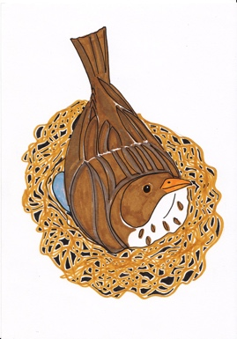

I hardly felt him in my hand,

he felt so soft and small.

I held him like a flower

upon my open palm.

I saw an eyelid quiver,

though he lay still and calm.

I never thought a bird so limp

could fly away so fast.

Unit 3 Days 1-4

**A Bird**

A bird came down the walk,

He did not know I saw;

He bit an angleworm in halves

And ate the fellow, raw.

And then he drank a dew

From a convenient grass,

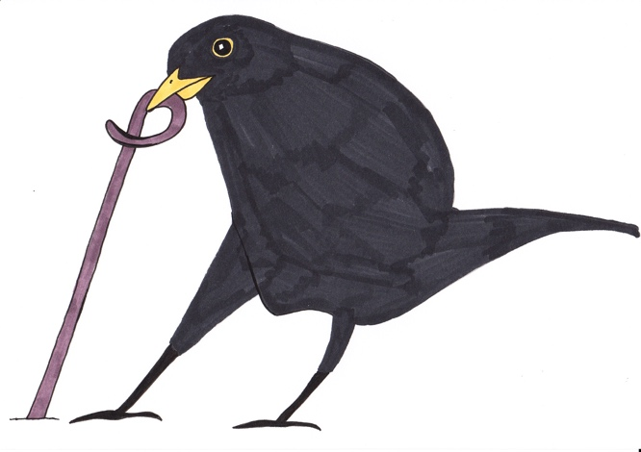And then hopped sidewise to the wall

To let a beetle pass.

*Emily Dickinson*

Unit 3 Days 1-4

**Poem comparison chart**

|  |  |  |  |
| --- | --- | --- | --- |
|  | **The Sparrow** | **A Bird** | **Duck’s Ditty** |
| **What is happening in the poem?** |  |  |  |
| **What is the overall mood of the poem?** |  |  |  |
| **What imagery is there? What poetic language is used?** |  |  |  |
| **Can you find and suggest words to describe the bird?** |  |  |  |
| **Can you describe the rhyme and rhythm?** |  |  |  |
| **What sort of poem is this?** |  |  |  |
| **Who is the person telling the poem? Who is the narrator?** |  |  |  |

*Unit 3 Days 1 and 3*

**Poem comparison chart *(partially complete)***

|  |  |  |  |
| --- | --- | --- | --- |
|  | **The Sparrow** | **A Bird** | **Duck’s Ditty** |
| **What is happening in the poem?** | *Bird flies into a window and stuns itself. It lies in a person’s hand until it flies off.* |  |  |
| **Can you describe the rhyme and rhythm?** | *Sets of 4 lines with lines 2 and 4 rhyming (A, B, C, B)*  *7-8 beats for line 1, and 6 beats for line 2 in each pairing* |  |  |
| **What is the overall mood of the poem?** | *Quite upbeat, despite the content* |  |  |
| **What imagery is there? What poetic language is used?** | *Simile – ‘like a flower’*  *Noun phrases – ‘speckled sparrow’* |  |  |
| **Can you find and suggest words to describe the bird?** | *Small, soft, limp, weak, a fighter* |  |  |
| **What sort of poem is this?** | *Narrative, rhyming, slightly humorous* |  |  |
| **Who is the narrator of (person telling) the poem?** | *The person holding the bird* |  |  |

*Unit 3 Days 1 and 3*