**Read the poems and answer the questions.**

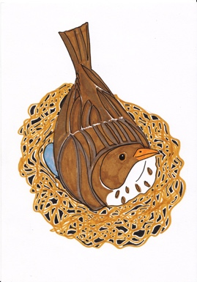

**The Sparrow**

I found a speckled sparrow

between the showers of rain.

He thought the window wasn’t there

and flew against the pane.

**1.** What did the poet find between the showers of rain? /2

………………………………………………………………………………………………………………………………………………………………………

…………………………………………………………………………………………………………………………………………………………………………

**2.** Why do you think the sparrow flew against the window pane? /1

a) It didn't see the window.

b) It was chasing another bird.

c) It was trying to find food.

I picked him up and held him.

He didn’t stir at all.

I hardly felt him in my hand,

he felt so soft and small.

**3.** How the poet describes the bird in his hands? /2

…………………………………………………………………………………………………………………………………………………………………………

…………………………………………………………………………………………………………………………………………………………………………

I held him like a flower

upon my open palm.

I saw an eyelid quiver,

though he lay still and calm.

I never thought a bird so limp

could fly away so fast.

**4**. What does the poet tell us about the sparrow's eye in the poem? /2

…………………………………………………………………………………………………………………………………………………………………………

…………………………………………………………………………………………………………………………………………………………………………

**5**. How did the poet describe holding the sparrow? /1

a) Like holding a rock

b) Like holding a flower

c) Like holding a feather

d) Like holding a stick

**6.** Why was the poet surprised by how fast the bird flew away? /2

…………………………………………………………………………………………………………………………………………………………………………

…………………………………………………………………………………………………………………………………………………………………………

**A Bird**

A bird came down the walk,

He did not know I saw;

He bit an angleworm in halves

And ate the fellow, raw.

**7.** Why do you think the bird decided to eat the angleworm raw? /1

1. It was in a hurry.
2. It didn't know how to cook.
3. It was attracted to the smell.

d) It's natural for birds to eat raw food.

And then he drank a dew

From a convenient grass,

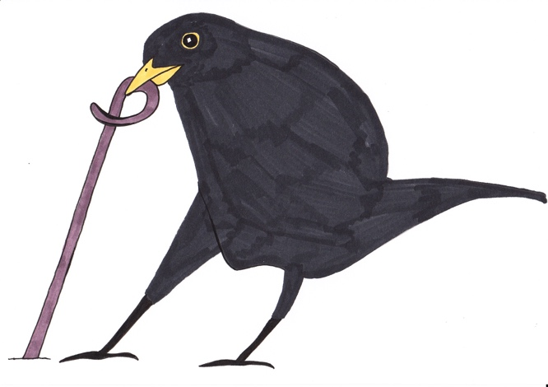And then hopped sidewise to the wall

To let a beetle pass

8. What did the bird do after drinking dew from the grass? /2

…………………………………………………………………………………………………………………………………………………………………………

…………………………………………………………………………………………………………………………………………………………………………

9. Compare the actions of the bird in "A Bird" with the actions of the sparrow in "The Sparrow." What similarities do you notice in how the birds behave in each poem? /2

…………………………………………………………………………………………………………………………………………………………………………

…………………………………………………………………………………………………………………………………………………………………………

…………………………………………………………………………………………………………………………………………………………………………