**Grammar Poster - Progressive Verb Forms – Present and Past**

To write in the **present progressive** or **past progressive** form:

Add – **ing** to the end of the main verb.

Add a helping verb before the main verb (**is, are, was, were**)

To show that a **present action** is in progress for a period of time, or at the same time as something else, we can use the **present progressive** form.

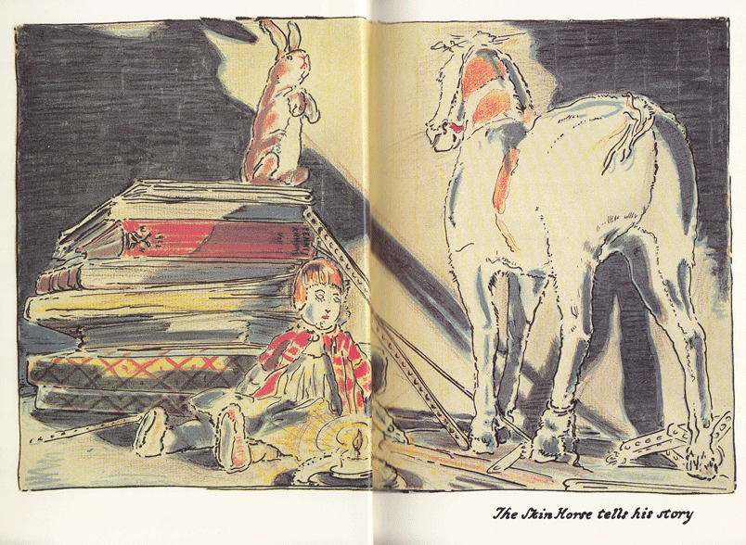

*The horse* ***is*** *explain****ing*** *to the rabbit.*

*They* ***are*** *talk****ing*** *while the boy is sleeping.*

Explaining something can take a while.

Their talking and the boy’s sleeping are happening at the same time.

To show that a **past action** was in progress for a period of time, or at the same time as something else, we can use the **past progressive** form.

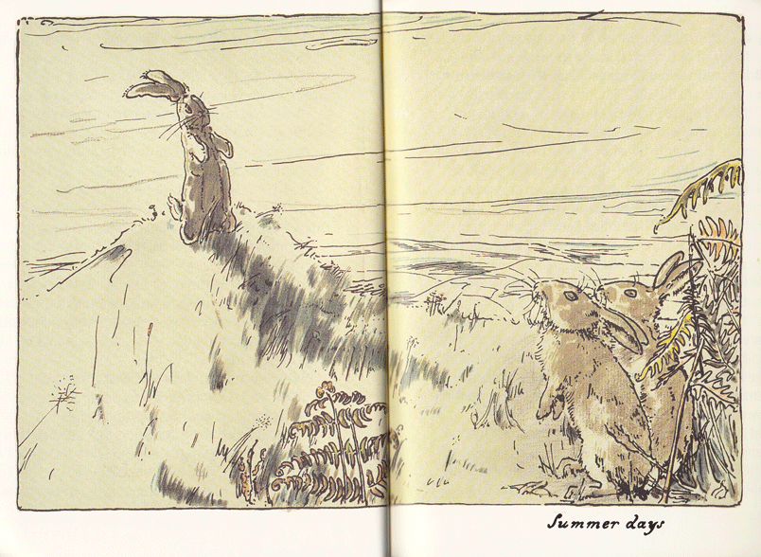

*The rabbit was watch****ing*** *the others.*

*The boy was play****ing*** *while the rabbit watched them.*

The rabbit was watching them for  
some time.

The boy playing and the rabbit watching happened at the same time.