Task :- Complete the algorithm and create a program in scratch using variable. The program should ask about their eye colour and display the eye colour that was displayed.

1)

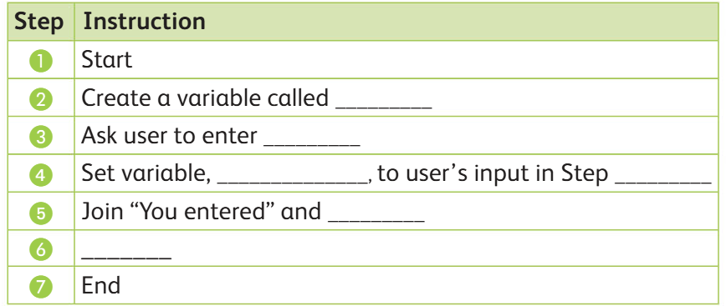

|  |  |  |  |
| --- | --- | --- | --- |
| **RUBRIC FOR SCRATCH PROGRAM.** | | | |
|  | 1 | 2 | 3 |
| Able to create a variable |  |  |  |
| Able to use Ask |  |  |  |
| Able to set the value for the variable |  |  |  |
| Able to Display the result |  |  |  |
| **Key**:   1. Needs more opportunity to develop this skill. 2. Beginning to demonstrate this skill. 3. Has achieved this skill. | | | |

2)

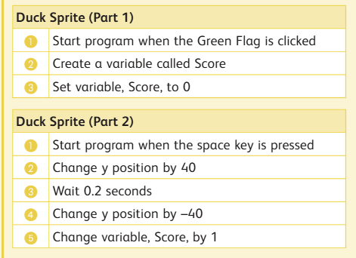

|  |  |  |  |
| --- | --- | --- | --- |
| **RUBRIC FOR SCRATCH PROGRAM.** | | | |
|  | 1 | 2 | 3 |
| Able to create a variable in part 1 |  |  |  |
| Able to set score |  |  |  |
| Able to do part 2 |  |  |  |
| Able to Display the score |  |  |  |
| **Key**:   1. Needs more opportunity to develop this skill. 2. Beginning to demonstrate this skill. 3. Has achieved this skill. | | | |