Write your understanding of the following pictures

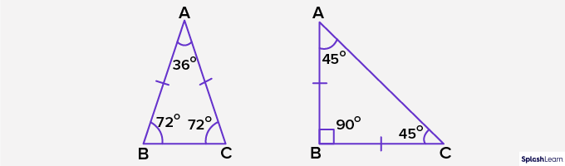 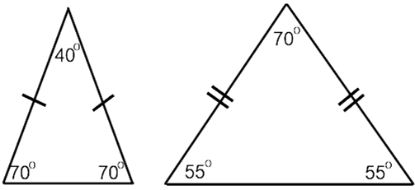

……………………………………………………………………………………………………..

…………………………………………………………………………………………………….

…………………………………………………………………………………………………….

Look at the regular pentagon

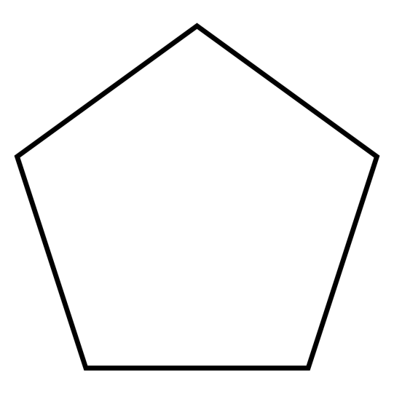

Join every corner to it's center as in the screen

What types of triangles are so formed? …………………………………………………………………..

What will be the measure of each central angle ? .....................................................................................

What will be the measure of each angles of the triangle ........................................................................

Now what is the measure of one interior angle? …………………………………………………………………….

What is the measure of each exterior angle? ............................................................................................

Repeat the same steps for regular hexagon to find the measure of each interior and exterior angle

