Revision- Software
1. | Software is installed on a computer to manage files, memory and multitasking.  - State the name of the software that can do these tasks.  ……………………………………………………………………………………..… [1]  - Give one task that the software allows the user to do to manage files.  ……………………………………………..…………………………………………. [1]
2. | Victoria develops a computer game to sell on a gaming website. She writes her program using English-like statements.  - State which type of programming language Victoria is using.  ............................................................................................................................................. [1]  (b) Victoria uses two different types of translators when creating the program for the computer game.  State which translator is the most suitable for the given tasks.  Give the benefits of using that translator for the task.  You must choose a different translator for each task.  (i)To translate the code during the development of the game.  Translator ..........................................................  Benefits ............................................................................................................................. ........................................................................................................................................... ........................................................................................................................................... ...........................................................................................................................................  ........................................................................................................................................... ........................................................................................................................................... [3]  (ii) To translate the final program and upload to the website for distribution, without the source code. Translator ..........................................................  Benefits ............................................................................................................................. ........................................................................................................................................... ........................................................................................................................................... ........................................................................................................................................... ........................................................................................................................................... ........................................................................................................................................... [3]
3. | Cameron writes software for coffee machines. He uses assembly language to write his software.  (a) Put a tick to show whether assembly language is an example of a high-level language,  a low-level language or machine code.  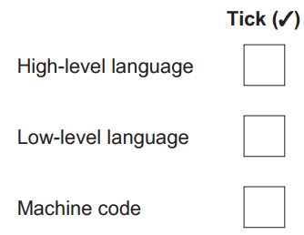 [1]  (b) Identify the translator that is required for assembly language.  ................................................................................................................................................... [1]  (c) Give two reasons why Cameron chooses to write the software for the coffee machines in  assembly language.  Reason 1 ..................................................................................................................................  ...................................................................................................................................................  Reason 2 ..................................................................................................................................  ................................................................................................................................................... [2]  (d) Give two drawbacks of using assembly language to write programs.  Drawback 1 ...............................................................................................................................  ...................................................................................................................................................  Drawback 2 ...............................................................................................................................  ................................................................................................................................................... [2]
4. | Padma opens an application on her computer.  An interrupt is generated to inform the Central Processing Unit (CPU) that the application has  been opened.  (a) Give three other examples of when an interrupt signal could be generated.  1 ................................................................................................................................................  2 ................................................................................................................................................  3 ................................................................................................................................................ [3]  (b) State what would happen if interrupt signals were not used in a computer. Give 2 reasons  ...................................................................................................................................................  .....................................................................................................................................................  …………………………………………………………………………………………………………….  ………………………………………………………………………………………………………........ [2]
5. | The programmers use Integrated Development Environment (IDE) when creating a program.  State what is meant by an IDE.  …………………………………………………………………………………………………………….  …………………………………………………………………………………………………………….  ……………………………………………………………….............................................................. [1]
6. | Look at these two pieces of code:  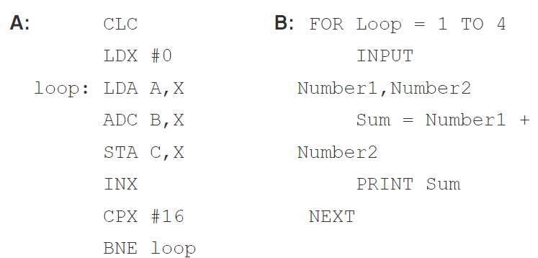  Which of these pieces of code is written in a high-level language?  ………………………………………………………………………………………………………….. [1]
7. | Which utility programs are described below?  - Software that rearranges data on a HDD to reduce the scattering of the data stored on the HDD.  ………………………………………………………………………………………………………  - Program that supplies static or moving images on a monitor when the computer has been idle for a period of time.  ……………………………………………………………………………………………………….  - Software that communicates with the operating system and translates data into a format understood by an input/ output device.  ……………………………………………………………………………………………………. [3]

