**Grade 3 Practical.**

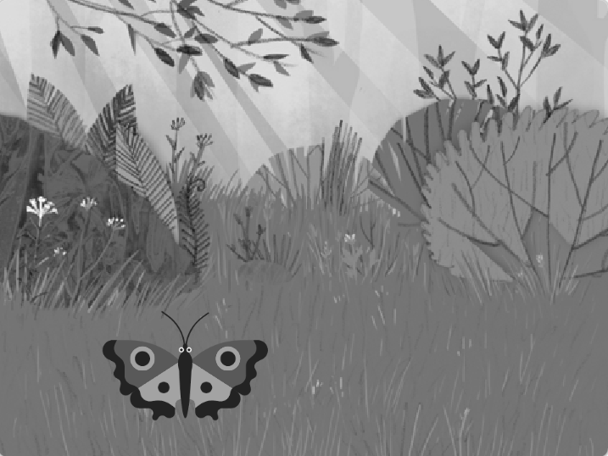**Task A:**

The students will create a program in scratch. The butterfly should fly up and gets smaller in size.

1. Add forest backdrop.

2. Add butterfly sprite.

3. Moves 20 positions up twice

4. pauses for 1 second

5. gets smaller in size by -10

6. moves 50 positions up twice

7. then gets smaller in size by -20.

Run the program. Does the butterfly fly up and gets smaller in size as it flies.

Can we combine any blocks of code?

Create a more concise program by combining and removing blocks.

Run the new program.

Does the butterfly fly up and gets smaller in size as it flies, just like the first program?

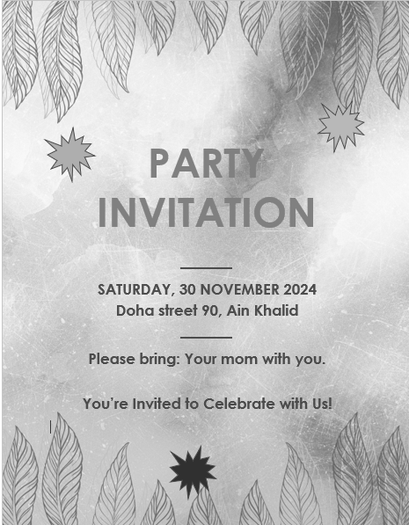**Task B:**

Create a party invitation card in

MS Word using a built-in or online

template:

1. Go to File 🡪 New🡪 scroll through

available templates.

Choose any flyer template.

OR

Go to File 🡪New 🡪use the search

bar to type the keywords party

or card.

Choose an appropriate

template.

2. Customize the text to fit your needs.

3. Enhance the design by adding various shapes.

4. Display your creativity in the final design.