**QUIZ-5**

**Audience Appreciation (Marking Scheme)**

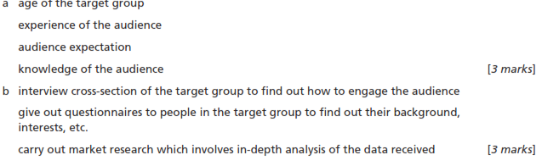



|  |  |
| --- | --- |
| **Items** | **Example** |
| Language used |  |
| Multimedia used |  |
| Length of presentation |  |
| Interactive Presentation |  |

[4]