**TERM 1 REVISION EXAM MARKING SCHEME**

**YEAR 9 - CS - Paper 2**

1. An algorithm has been written to:

• set 100 elements of the array Reading [1:100] to zero

• input integer values between 1 and 100

• end the process with an input of –1

• reject all other values

• Count and output the number of times each value is input, starting with the largest value.

(a)Complete the pseudo code algorithm:

01 FOR Count 1 TO....................................................................................................

O2 Reading [Count] 0

03 NEXT Count

04 OUTPUT "Please enter next reading”

05 INPUT Value

06 WHILE Value <> -1 DO

07 IF Value <= 0 OR...................................................................................................

08 THEN

09 OUTPUT "Reading out of range"

10 ELSE

11 Reading [Value]........................................................................................

12 ENDIF

13 OUTPUT "Please enter next reading”

14......................................................................................................................................

15 ENDWHILE

16 Count 100

17 REPEAT

18 OUTPUT "There are ", .............................................................................,

“readings of ", Count

19 Count...................................................................................................................

20 UNTIL Count = 0 [6]

(b) Describe how the algorithm could be changed so that it does not output any counts of zero.

..................................................................................................................................................

..................................................................................................................................................

..................................................................................................................................................

..................................................................................................................................................

..................................................................................................................................................

................................................................................................................................................. [3]

2. Tick (3) one or more boxes in each row to match the type(s) of test data to each description.

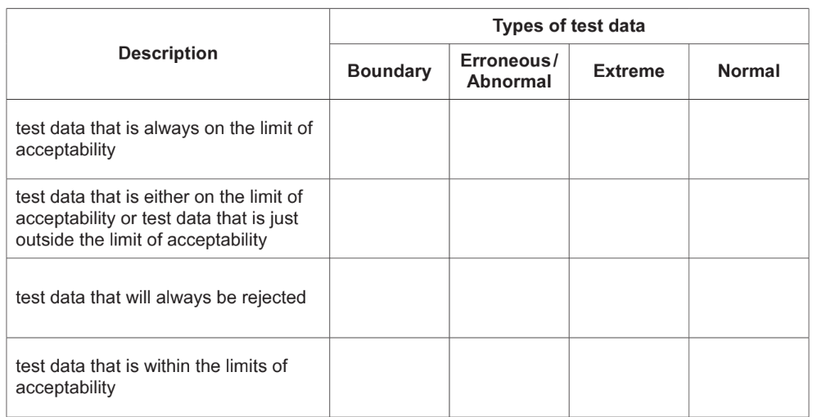

[4]

3. Describe what is meant by the terms variable and constant and give an example of each in your

answer.

Variable............................................................................................................................................

..........................................................................................................................................................

..........................................................................................................................................................

..........................................................................................................................................................

Constant...........................................................................................................................................

..........................................................................................................................................................

..........................................................................................................................................................

......................................................................................................................................................... [4]

4. The pseudo code represents an algorithm.

The pre-defined function DIV gives the value of the result of integer division.

For example, Y = 11 DIV 4 gives the value Y = 2

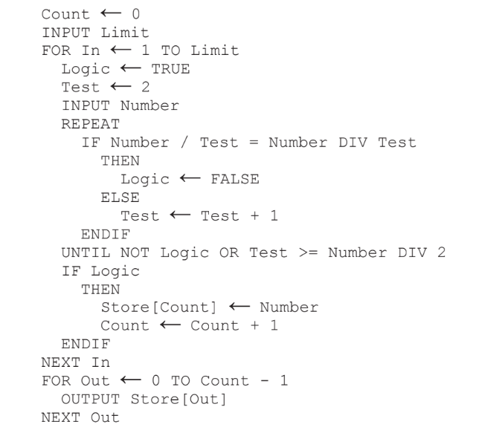

(a) Complete the trace table for the algorithm using this input data: 5, 9, 5, 8, 10, 7

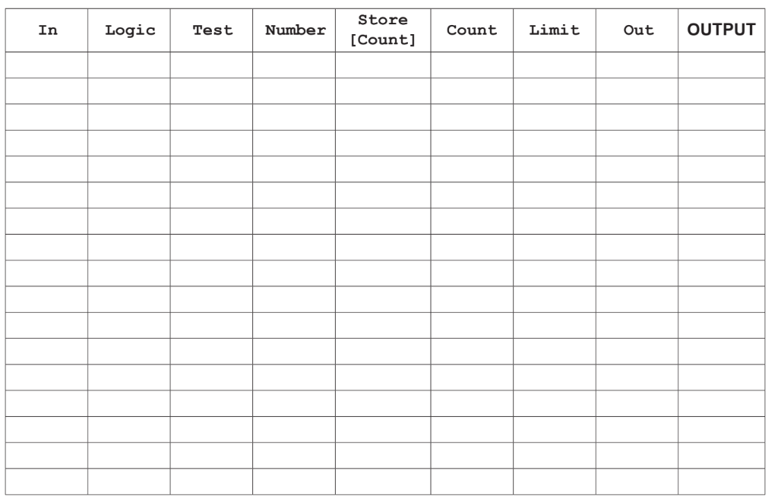[7]

(b) State the purpose of this algorithm.

...................................................................................................................................................

...................................................................................................................................................

...................................................................................................................................................

.................................................................................................................................................. [2]

(c) This algorithm only works for numbers that are 3 or greater.

Describe how you could change this algorithm to make sure that only numbers that are 3 or greater are entered. Any pseudo code statements used in your answer must be fully described.

...................................................................................................................................................

...................................................................................................................................................

...................................................................................................................................................

...................................................................................................................................................

...................................................................................................................................................

...................................................................................................................................................

...................................................................................................................................................

...................................................................................................................................................

...................................................................................................................................................

................................................................................................................................................... [3]

5. An algorithm allows a user to input their password and checks that there are at least eight

characters in the password. Then, the user is asked to re-input the password to check that both

inputs are the same. The user is allowed three attempts at inputting a password of the correct

length and a matching pair of passwords. The pre-defined function LEN(X) returns the number of

characters in the string, X

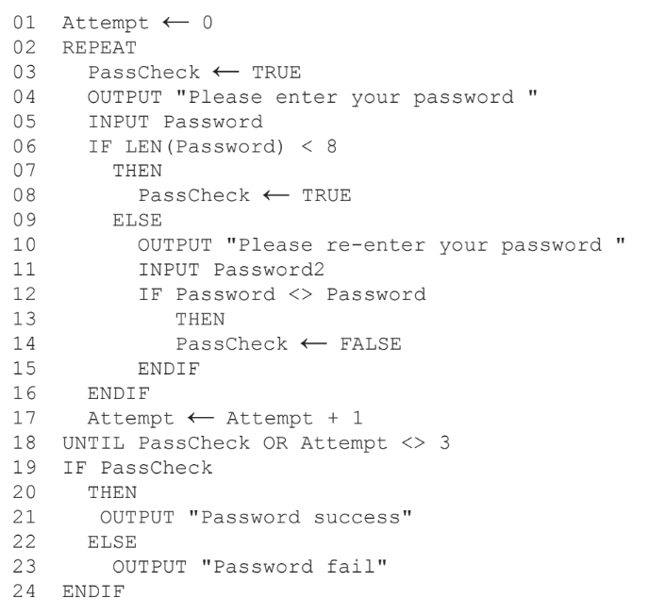

(a) Identify the three errors in the pseudo code and suggest a correction to remove each error.

Error 1.......................................................................................................................................

Correction.................................................................................................................................

Error 2.......................................................................................................................................

Correction.................................................................................................................................

Error 3.......................................................................................................................................

Correction................................................................................................................................. [3]

(b) The algorithm includes two types of check on the data input.

Identify and describe each type of check.

Type of check 1........................................................................................................................

Description................................................................................................................................

...................................................................................................................................................

Type of check 2........................................................................................................................

Description................................................................................................................................

................................................................................................................................................... [4]

(c) Give two sets of test data for this algorithm and a reason for choosing each set.

Each set of test data and its reason must be different.

Set 1.........................................................................................................................................

Reason.....................................................................................................................................

...................................................................................................................................................

Set 2.........................................................................................................................................

Reason.....................................................................................................................................

................................................................................................................................................... [4]