Clumsy Clive On Pythagoras and Trigonometry 1
Clive is tackling his Pythagoras and trigonometry homework and knows that he’s made mistakes somewhere.
Can you spot and correct the mistakes Clive has made?
Can you explain what mistakes Clive has made, and maybe give him some tips so that he (hopefully) doesn’t make them again?
Question 1:
Find the length of the side $a$ giving your answers to $1$ decimal place:
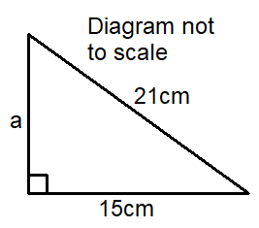
Clive’s answer: | Your answer:
It’s a right-angled triangle and we are finding a short side:
$$\sqrt{21-15}=\sqrt{6}$$
Answer:
$$2.4$$

What mistake has Clive made?

Question 2:
Find the size of angle $b$ giving your answer to the nearest degree:
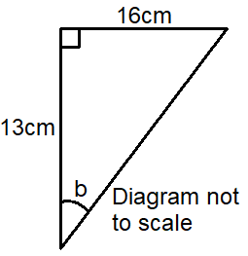
Clive’s answer: | Your answer:
We have the adjacent and opposite sides so will use “tangent”:
$$\tan{b}=\frac{13}{16}$$
$$b=\tan^{-1}\left(\frac{13}{16}\right)$$
Answer:
$$39°$$
What mistake has Clive made?

Question 3:
Find the length $c$:
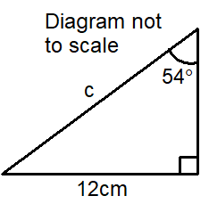
Give your answer to $3$ significant figures.
Clive’s answer: | Your answer:
We have the opposite and the hypotenuse so must use “sine”:
$$\sin{54°}=\frac{12}{c}$$
$$c=12×\sin{54°}$$
Answer:
$$9.7cm$$

What mistake has Clive made?

