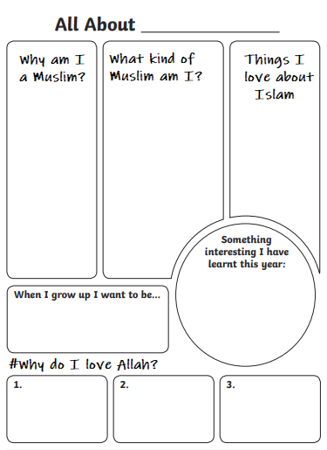

**# Anything You want your Teacher to know about You?**

1. **Complete the Ven Diagram by writing the qualities of a good teacher and a good student:**

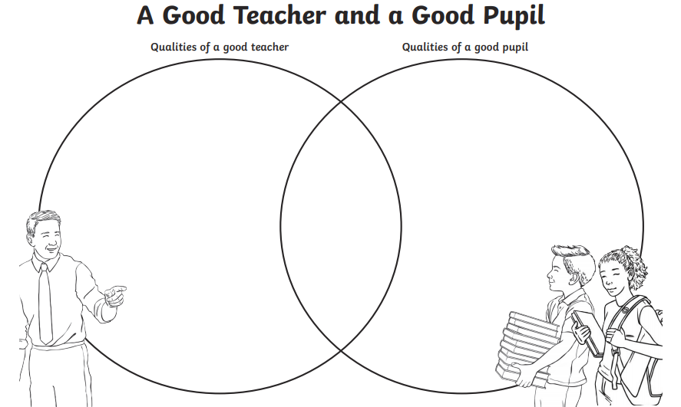

**2-Write the rules you would like to have in your class as a teacher:**