1. **Choose the words from bank. /5**

steps understand arrange solution algorithms

1. We create algorithms to help solve a problem or perform a task.
2. To write an algorithm, we must understand the problem and come up with a solution that makes sense.
3. We can use logical thinking to break down a problem into smaller pieces and think about the steps that give us the results we need.
4. Arrange the steps in an order that makes sense.
5. **Match the following with the file type. /5**

|  |  |
| --- | --- |
| 1. Text | 1. Moving pictures with sound captured with a camcorder |
| 1. Audio | 1. Apps and programs that we play and allow us to have fun |
| 1. Video | 1. Music, sound or voice stored on the computer |
| 1. Game | 1. Photographs, pictures and drawings |
| 1. Image | 1. A combination of letters and numbers |

|  |  |  |  |  |
| --- | --- | --- | --- | --- |
|  |  |  |  |  |
| **E** | **C** | **A** | **B** | **D** |

1. **State whether the statement is true or false. /4**

|  |  |
| --- | --- |
| Image and video files are the same. | F |
| A text file does not contain any numbers. | F |
| A computer-controlled device can be found at a supermarket. | T |
| The Internet of Things is a place on the internet to purchase things. | F |
| Robots in a factory can build items. | T |

1. **Answer the following questions: /6**
2. How can we describe the difference between characters with **code** and **static objects** in a program, and why might it be useful to include both in our programs?

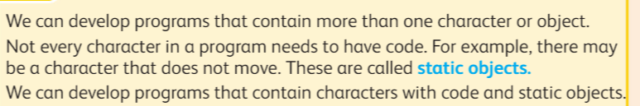_ It is useful to include both in our programs to make story. _____________________________________________________________________________________________________________________________________

1. How are files **organized** on a computer's hard drive? Why is it important for files to have different **names** and be **stored** in folders?

___________________________________________________________________

1. Name any **four** types of files you might find on a computer.

|  |  |
| --- | --- |
| 1) | 2) |
| 3) | 4) |



1. Smart devices can be found in the home, school or in industries.

Name any **four** **smart devices**:

|  |  |
| --- | --- |
| 1) | 2) |
| 3) | 4) |

1. List three **computer-controlled devices**.
2. ________________________________
3. ________________________________
4. Identify three roles of **robots in the factory**.
5. Robot handle material
6. Robot build things
7. Robot Inspect