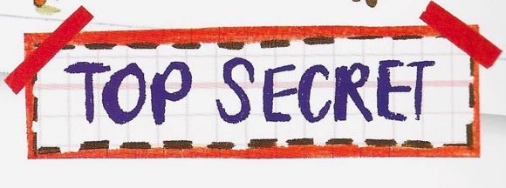

***… Sentences!***

***Read the sentences below and turn them into the sort of sentence indicated***

1. Here is a statement – *The explorer was on Everest.*

Rewrite it as a question: ______________________________________________________________________________________

______________________________________________________________________________________

2. Here is another statement – *We found the map in Egypt*.

Rewrite it as a question: ______________________________________________________________________________________

______________________________________________________________________________________

3. Here is a command – *Eat these beetles*.

Rewrite it as a statement: ______________________________________________________________________________________

______________________________________________________________________________________

4. Here is another command – *Open the treasure chest.*

Rewrite it as a statement: ______________________________________________________________________________________

______________________________________________________________________________________

5. Here is an exclamation – *What awful pirates!*

Rewrite it as a statement: ______________________________________________________________________________________

______________________________________________________________________________________

6. Bruno makes the exclamation – *How brilliant!* when he and Michael catch the Pirate King

Rewrite it as a statement: _________________________________________________________________________

Unit 3 Day 2

_________________________________________________________________________

***Pirate Ship Sentences***

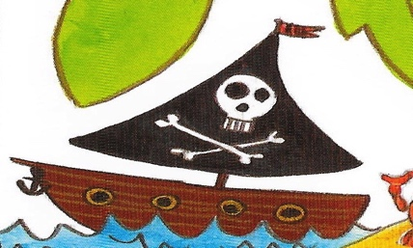

1. **Read the sentences below.**
2. **In the brackets, say what kind of sentence each is – a statement, exclamation, command or question.**
3. **Turn each sentence into the sort of sentence indicated.**

*1. The explorer was on Everest. ( ________________________ )*

Question: *______________________________________________________________________________*

*______________________________________________________________________________________*

*2. Is Bruno awesome? ( __________________________ )*

Exclamation: *____________________________________________________________________________*

*_______________________________________________________________________________________*

*3. Where is the map?* *( ___________________________ )*

Statement:  *____________________________________________________________________________*

*______________________________________________________________________________________*

*4. Look out - baddies are coming! ( ___________________________ )*

Question: *______________________________________________________________________________*

*______________________________________________________________________________________*

*5. Michael ate beetles and snakes. ( ________________________ )*

Exclamation: *____________________________________________________________________________*

*_______________________________________________________________________________________*

*6. Where is the treasure chest? ( ________________________ )*

Command: *______________________________________________________________________________*

*_______________________________________________________________________________________*

*7. Get on the boat. ( ________________________ )*

Statement: *______________________________________________________________________________*

*_______________________________________________________________________________________*

*8. Pirates ahoy! ( ________________________ )*

Question: *_______________________________________________________________________________*

*_______________________________________________________________________________________*

*9. Michael and Bruno had to walk the plank. ( ________________________ )*

Command: *______________________________________________________________________________*

*_______________________________________________________________________________________*

*10. Is this the Orient Express? ( ________________________ )*

Statement: *______________________________________________________________________________*

*_______________________________________________________________________________________*

Unit 3 Day 2