**WORKSHEET**

**Transmission modes**



How communication can be done between the two devices?

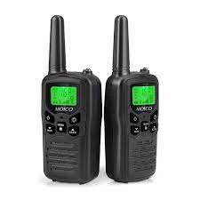One way two way (not at a same time) two way (at a same time)



How communication can be done between the two devices?

One way two way (not at a same time) two way (at a same time)



How communication can be done between the two devices?

One way two way (not at a same time) two way (at a same time)

Key Points

__________________________________________________________________________________

__________________________________________________________________________________

__________________________________________________________________________________

__________________________________________________________________________________

__________________________________________________________________________________

__________________________________________________________________________________

__________________________________________________________________________________

__________________________________________________________________________________

__________________________________________________________________________________

__________________________________________________________________________________

__________________________________________________________________________________

__________________________________________________________________________________

__________________________________________________________________________________

__________________________________________________________________________________

__________________________________________________________________________________

__________________________________________________________________________________

__________________________________________________________________________________

__________________________________________________________________________________

__________________________________________________________________________________

__________________________________________________________________________________

__________________________________________________________________________________

__________________________________________________________________________________