Healthy or not?

Natural foods like vegetables, fruits, nuts, eggs, meats, whole grains, etc.

contain different assortments of nutrients.

Would you consider each meal healthy or not?

**Explain your answer in the box.**

**A**

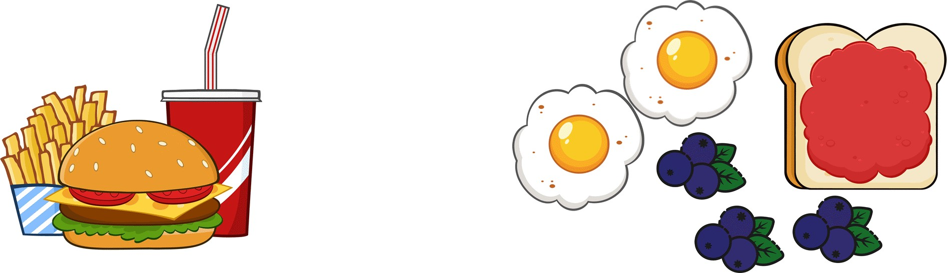

**B**



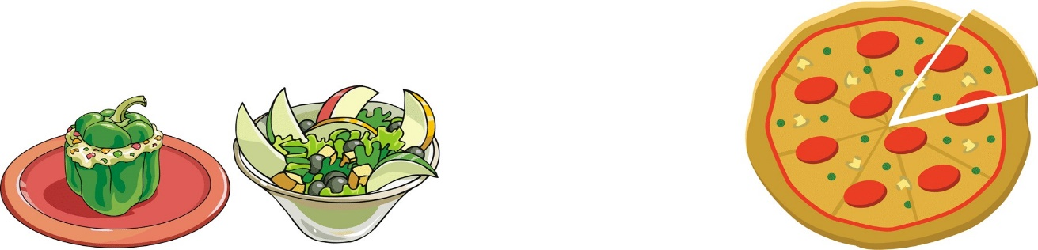

**C**

**D**



9) Out of the meals listed above (A, B, C, and D), which one do you think is the healthiest balanced diet?

__________________________________________________________

10) Out of the meals listed above (A, B, C, and D), which one do you think is the least healthy diet?

___________________________________________________________