**Negotiating Styles**

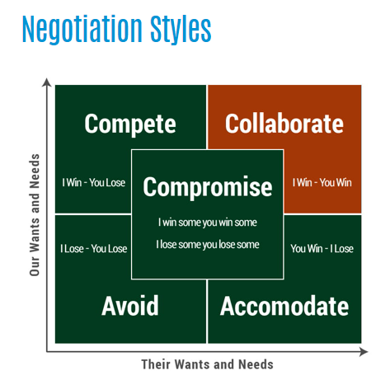

Give an example of :

**Compete Negotiation Style : …………………………………………………………………………………………………………………**

**…………………………………………………………………………………………………………………………………………………………….**

**Collaborate Negotiation Style : ……………………………………………………………………………………………………………**

**……………………………………………………………………………………………………………………………………………………………**

**Avoid Negotiation Style : ……………………………………………………………………………………………………………………**

**…………………………………………………………………………………………………………………………………………………………..**

**Accommodate Negotiation Style : ……………………………………………………………………………………………………..**

**…………………………………………………………………………………………………………………………………………………………..**

**Compromise Negotiation Style : ………………………………………………………………………………………………………….**

**……………………………………………………………………………………………………………………………………………………………**

Abdul has to make something in order to enter a school competition. Using his grandmothers recipe, he starts producing home made lemonade . Afterwards, his friends all ask him to make some for them . Demand increases quickly and Abdul plans to open a Saturday market stall . Abdul needs permission from the school to be allowed to apply for the stall .

Write down possible benefits and drawbacks of Abduls proposal.

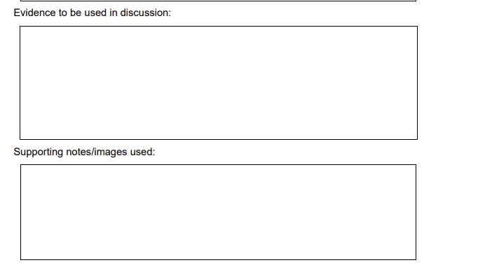

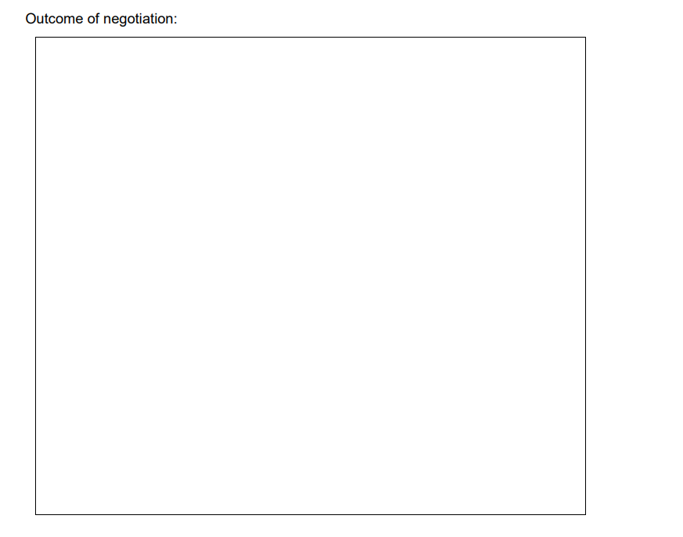

**NOTES :**

